**THESIS CORNER: AN ONLINE REPOSITORY SYSTEM FROM PROPOSAL TO ARCHIVING**

A Capstone Project

Presented to the Faculty

of Information Technology Department

of the College of Hospitality Management Business Administration and Computing

Pangasinan State University San Carlos Campus

In Partial fulfillment

of the Requirements for the Degree

Bachelor of Science in Information Technology

De Vega, Diosdado Jr. B.

Paris, Alfred D.

Sanchez, Jayson O.

Santos, Rea V.

Decembers 2023

# APPROVAL SHEET

In partial fulfillment of the requirements for the degree of Bachelor of Science in Information Technology, this capstone project entitled **“Thesis Corner: An online repository system from proposal to archiving”** has been prepared, presented, and submitted by **Diosdado B. De Vega Jr., Alfred D. Paris, Jayson O. Sanchez,** and **Rea V. Santos** who successfully passed the Final Oral Examination.

**REYNALD D. GLORIA, MAEd NAPOLEON CAMUS M. HERMOSO, MIT**

Critic Reader Project Adviser

Approved by the Committee for Oral Examination

**CHRISTIAN S. DELA CRUZ, DIT**

Chairman

**CLARENCE JOY B. NANLABI JULIET V. MENOR, DIT**

Member Member

Accepted in partial fulfillment of the requirements for the degree Bachelor of Science in Information Technology.

**JULIET V. MENOR, DIT** **LIZA L. QUIMSON, EdD**

College Dean, CHMBAC Campus Executive Director

# ABSTRACT

Title: **THESIS CORNER: AN ONLINE REPOSITORY SYSTEM FROM PROPOSAL TO ARCHIVING**

Developer: De Vega, Diosdado Jr. B., Paris, Alfred D., Sanchez, Jayson O., and, Santos, Rea V.

Institute: Pangasinan State University San Carlos Campus

San Carlos City, Pangasinan

Degree: Bachelor of Science in Information Technology

Adviser: Napoleon Camus M. Hermoso, MIT

Date:

# The THESIS CORNER: AN ONLINE REPOSITORY SYSTEM FROM PROPOSAL TO ARCHIVING was created to offer an efficient, quick, secure, and dependable platform for storing research files at Pangasinan State University San Carlos Campus. It simplifies data management, handled solely by the administrator, while allowing students to access certain information from anywhere with an internet connection. The development methodology employed for this system is Agile Scrum, known for its iterative and incremental approach, enhancing productivity and adaptability to changing requirements, ultimately aligning with evolving business objectives.

WAMMI stands for Website Analysis and Measurement Inventory. It is built on commercial expertise gained from evaluating software for usability and international software standards since the early 1990's. WAMMI is used in most market sectors (banking, finance, insurance, pensions, travel, telecom, ITC) and all types and sizes of transactional sites (B2B/e-commerce). WAMMI has been extended to measure user experience of corporate Intranets. User experience in the public sector (e-government) is critical. WAMMI has been broadly recommended by the UK guidelines for public sector websites. It is also used regularly by EU-funded projects (H2020) to assess how well project website goals are being met from the target group/stakeholder perspective. The survey concludes that the overall average rating for the THESIS CORNER: AN ONLINE REPOSITORY SYSTEM FROM PROPOSAL TO ARCHIVING is 4.0, indicating that the system excels in terms of Learnability, Efficiency of Use, User Satisfaction, and Reliability.

# ACKNOWLEDGMENT

We the developers wish to express our warmest and deepest gratitude to the people who contributed to the possibility and completion of this study.

We would therefore like to offer our sincere thanks to all of them. We extend our gratitude to **Dr.** **LIZA L. QUIMSON** for the guidance, unconditional support, and love.

We warmly thank **Dr.** **JULIET V. MENOR**, our College Dean and panel member for sharing her knowledge and endless encouragement to help us finish this study.

We are incredibly grateful for having such a good adviser like you, your comments, and all efforts in checking this study have been much appreciated.

We also want to send our warmest thanks to the program chairperson and capstone research panel**, Dr. CHRISTIAN S. DELA CRUZ**, our program chair of the IT Department and panel member for guiding and giving ideas and insights that were used to complete our study.

We would also like to thank **Dr.** **BENSON LIESTER A. FLORES** and **Mr. CLARENCE JOY B. NANLABI**, the panel members who gave vital suggestions, input, and ideas that were used for areas of improvement in our study. We developers valued your suggestions and ideas that we used to improve our study.

We extend our gratitude to **Mr. NAPOLEON CAMUS M. HERMOSO**. Our capstone advisor deserves sincere appreciation for his unwavering support, valuable input, and consistent guidance throughout our research project. His expertise, insightful suggestions, and significant contributions were pivotal in the completion of our study.

We would also like to thank our friends and family for their unending support and for helping us accomplish this project. Thank you for your helping hands, concern, and moral support during the development of this project.

And our **ALMIGHTY GOD**, for all the blessings he granted forgiving the proponent the knowledge, wisdom, and strength, enabling them to fulfill the study.

And to all who have exerted effort and inspired them to make the project possible,

THANK YOU VERY MUCH!

The Developers

# DEDICATION

Our

families, whose

everlasting love, support, and inspiration

have served as the catalyst for our academic path.

Thank you to our instructors and mentors for molding us

minds and igniting our desires. For the endless hours of study sessions,

late-night conversations, and shared victories and struggles with our friends and

coworkers that have made this journey special. To the search for knowledge,

which offers unending inspiration and the prospect of a better tomorrow.

This thesis is dedicated to everyone who has touched our lives in

some way and helped us grow and achieve our goals. Our

biggest source of inspiration has been your

faith in us. for knowledge as they

patiently and wisely

taught

us.

De Vega, Diosdado Jr. B.

Paris, Alfred D.

Sanchez, Jayson O.

Santos, Rea V.

# table of contents

Title page I

APPROVAL SHEET ii

ABSTRACT iii

ACKNOWLEDGMENT v

DEDICATION vii

table of contents viii

LIST OF tables ix

Implementation Plan 4 ix

LIST OF FIGURES x

Chapter 1 1

**INTRODUCTION 1**

**1.1 Context of the Project 1**

**1.2 Objectives of the Project 3**

**1.3 Significance of the Project 3**

**1.4 Purpose and Description 4**

**1.5 Scope and Limitations 5**

Chapter 2 9

**REVIEW OF RELATED LITERATURE AND STUDIES 9**

**2.1 Related Literature 9**

**2.2 Summary of Related Literature 26**

Chapter 3 39

**METHODOLOGY 39**

**Hardware and Software Requirements 40**

**Hardware Requirements for System Development 40**

**Software Requirements for System Development 41**

Chapter 4 59

**RESULTS AND DISCUSSION 59**

Chapter 5 74

**SUMMARY, CONCLUSIONS AND RECOMMENDATION 74**

References 78

# LIST OF tables

**Summary Of Related Literature 1**

**Table 3.1 Software Requirements 2**

**System Development Software Requirements 3**

**Implementation Plan 4**

**Scales and Points in the Instrument 5**

# LIST OF FIGURES

**Concept Map of An online repository system from proposal to archiving2**

**Figure 3.0 Agile Methodology 5**

**Figure 3.1 ERD 6**

**Figure 3.2 Use Case 6**

**Figure 3.3 Web Network Diagram 6**

**Figure 4.1. Existing Process of the Capstone and Thesis………………………….60**

# Chapter 1

## INTRODUCTION

### Context of the Project

The purpose of these studies is to investigate the current state of manual archives inside selected colleges, with the goal of better understanding their function in preserving institutional history, assisting administrative operations, and supporting academic research. We will specifically look at how manual archives contribute to the College of Hospitality Management, Business Administration, and Computing's unique issues and requirements.

Digital archiving is important for businesses because it allows for the storage and organization of important documents and data. Malak (2023) this can include financial records, employee information, and customer data. By keeping all this information in a digital format, it is easy for businesses to access and use it as needed. It is important to archive the data so it can be easily accessed in the future. In today’s world, there are many risks involved with data and if you do not take care of them, they will come back to haunt you later. Archives can be dangerous in that they are prone to tampering and destruction, as well as accidental destruction from natural disasters. Some data is simply lost over time due to decay or due to the user’s lack of knowledge on how long their device has been in use. Lastly, data can be lost or deleted from devices. The only way to get data back is through backups and synchronizing, which also require a lot of time and resources. This is why it is important to have a plan in place for how you will do this. Since the early 2000s, a growing body of literature has been interrogating colonial archives and the continuing effects of colonial modes of archiving and research on knowledge production, memory, and identity. By examining the colonial archives built by American forces during the US rule of the Philippines, between 1898 and 1916, Cheryl Beredo’s Import of the Archive contributes to this literature by both tracing out the archival logic of American colonial rule and situating American archives and archiving within what historian Tony Ballantyne has called the imperial web through which archival materials, peoples, and ideas circulated.

While its examination of the US’s imperial archival logic makes Import worth reading, Beredo’s book is important for also challenging the Eurocentrism that continues to marginalize colonies as sites where the modern world and its archiving were developed. Focused on the years between the outset of the Spanish-American War and the Philippine Autonomy Act, Beredo’s exploration of the changing role of archives in America’s imperial exploits is nonetheless expansive. Comprising five chapters, Import is primarily organized around three ways that archives were involved in US imperial politics: supporting the colonization of the Philippine islands and their inhabitants; instigating an anti-imperial archive; and transforming the islands and their people through land registration. On the first of these points, Berendo argues that American officials saw Spain’s colonial archives as a key spoil of the Spanish-American War because these records were an essential means of coming to know the islands and their inhabitants to rule it and them.

However, as Beredo points out, the colonial archives also came to support the US’s moral argument that its imperialism was benevolent. As part of America’s self-appointed “white man’s burden” of modernizing the Philippines, archiving efforts were placed alongside other civil engineering and education projects as proof of benevolent efforts to create a modern, efficient colonial bureaucracy, efforts that concealed the violence of martial order. Discourses of US benevolence in the Philippines were used less to convince Filipinos of America’s good intentions than to continue to garner support within the States for imperial expansion in the face of a growing anti-imperialist movement. Beredo shows the colonial archives as the source.

### 1.2 Objectives of the Project

The Thesis Corner project aims to develop An online repository system from proposal to archiving and proposal checker for a Bachelor of Science in Information Technology. Specifically, it aims to:

1. Identify the existing manual process of Pangasinan State University San Carlos regarding the monitoring of the College Of Hospitality Management, Business Administration and Computing (CHMBAC) thesis project;
2. To determine the features of the system that align with the functional and non-functional requirements; and,
3. To test the acceptability of the system.

### 1.3 Significance of the Project

This project will be valuable and significant to students, faculty, university, and future developers. The result of this project may help the following individuals and groups:

**College Of Hospitality Management, Business Administration and Computing (CHMBAC).** Refers to the college that comprises the degree courses Business Administration, Information Technology, Hospitality Management, and Office Administration.

**Super Admin.** Refers to a user with the highest level of administrative privileges, where it can manage all the users and archives.

**Sub Admin** refers to a subordinate or secondary administrator within a system or organization, where in this case is the chairperson and dean of each department**.**

**Administrator** refers to the librarian of Pangasinan State University, San Carlos City Campus.

**Student** refers to the end users of the system.

**Faculty** refers to the faculty members of every department, the faculty members can use the system to view and find capstone projects that are stored in the database. They can also manage an archive and manage student accounts.

**Future developer** refers to the students who can use this project to serve as the basis or as a reference and guide for future researchers who wish to conduct the same study, or any study related to the topic.

### 1.4 Purpose and Description

The system is designed to be user-friendly, with an intuitive interface that allows administrators to quickly upload, organize, and access documents. Its goal is to provide a reliable and efficient way to manage and store important data and documents while ensuring the confidentiality and security of sensitive information. In addition, it has sophisticated search and filtering features that make it easy to quickly locate files or information.

Capstone Corner is created with security in mind using the middleware limitations and token functionality of the Laravel framework in addition to a user-friendly interface. It has advanced encryption and access restrictions to ensure that only authorized people can access sensitive data. The compatibility checker provides end users with a platform on which they can check if their proposed system project is accepted. The platform first checks the user-entered header and checks if it has similarities with other systems. Second, the problem will be checked to see if it meets the PSU's composite criteria. Overall, Capstone Corner provides the user’s with a safe and reliable storage system that is easy to use and maintain. With compatibility testing tools students can check the feasibility of the system that will be provided to them.

### 1.5 Scope and Limitations

Scope The proposed project is entitled “Thesis Corner: User-friendly and Secure Storage System” for Pangasinan State University San Carlos Campus. The system will be downloaded and stored online for convenient access by student users. The system has three access levels Administrator, Faculty, and Student. The college dean will be an administrator who can manage the system, such as reviewing thesis projects, and student and faculty accounts, and can view Thesis projects that have been uploaded to the system. The faculty will upload the student's final thesis project and view and search project summaries. Students can view files, search for files, and use the compatibility checker. The system allows administrators to insert and update the latest information into the database, such as new summary projects and new account registrations. The system also allows administrators to manage all tasks including adding, updating, monitoring, and storing data from the students platform of San Carlos campus of Pangasinan State University in a database. As a result, all data is easier to handle and manage by administrators. All research is effectively done using the name of the capstone project. Students can research capstone projects anytime, anywhere with an internet connection. Students can search and view the title of the platform.

The system does not include the following features like file creation, private messages, chat, video, and audio. The system only accepts files in PDF format. For system compatibility, the system can only check the title if it has similarities with the database abstraction projects. In the proposed capstone project, the features and issues will be sent to the faculty and administrators whether they meet the criteria and feedback will be returned to the students.

**1.6 Definition of Terms**

The following terms are defined as operational and logical for a better understanding of this project.

**MVC Architecture**. According to Sunardi and Suharjito (2019), MVC design patterns were well-known patterns and were used for interactive software system architectures. The way the MVC method works was to separate the main components such as data manipulation (model), display/interface (View), and the process (Controller) so that it was neater, structured, and easily developed.

Currently, the students do not have a system that they can use to find a similar Thesis title that they have in mind to propose. Because the student can have the same idea of a capstone title that already exists in the library or is already under development. As a result, the students ended up proposing a capstone that already existed. To address the stated problem, we proposed the development of the 'THESIS CORNER ARCHIVING SYSTEM.' This system will be built using the MVC (Model View Controller) architecture model and will leverage PHP Laravel and Slim frameworks to provide developers with a robust solution for archiving and managing their capstone projects.

**Archive.** This was the place where documents and records were stored.With the emergence of the modern state, it became the storehouse for the material from which national memories were constructed. Archives also housed the proliferation of files and case histories as populations were subjected to disciplinary power and surveillance (Featherson, 2019). The archive, which housed priceless knowledge, was essential to study. To store and retrieve it effectively, it had to be carefully arranged. Faster content location was made possible through categorization and search features. A thorough record of modifications was ensured through revision history. Measures for data integrity protected from loss or corruption. Redundancy and safe backups guaranteed ongoing accessibility**.**

**Thesis Corner**. Referring to an archiving system area allocated to the thesis project. It acts as a focal point for collecting and organizing important thesis project data.

**Compatibility.** This referred to the ability of software and hardware from various sources to work together without having to be altered to do so. This meant that programs, devices, and systems had to interact with each other without issues arising (Hanna, 2019). This involved how well the Capstone Corner worked with other parts of the archiving system and how well it integrated. For the best system performance, it underlined the significance of fluid communication and data sharing.

**Criteria**. This referred to the set of requirements or standards used to assess the effectiveness and quality of the system. To ensure the success of a user-friendly system, THESIS CORNER emphasized the importance of several key factors. This included prioritizing user identification, implementing access controls, and leveraging the security features provided by Laravel. Effectively managing databases and seamlessly handling media were aspects that should not be overlooked.

**Laravel Framework.** Laravel was an open-source PHP web framework developed and maintained by Taylor Otwell to provide a more advanced alternative to the CodeIgniter framework. Its architectural patterns were majorly based on Symfony. Laravel was a PHP web application framework that was used for developing web applications and APIs. It provided a set of tools and features that made it easier for developers to build robust and scalable web applications quickly and efficiently. The first and best advantage of using the Laravel framework was that it followed - Model, View, and Controller-based architectural patterns and it had an expressive beautiful syntax which made it object-oriented (Patil, 2023.). Laravel, the chosen framework for the 'THESIS CORNER; A SECURE AND USER-FRIENDLY SYSTEM' project played a role in ensuring its success. The strong features and security measures offered by Laravel provided a foundation for protecting data. User authentication, authorization, and database management were made easier with Laravel, which was essential when dealing with materials. The framework’s capabilities in handling files made document management more streamlined while its testing suite guaranteed system reliability.

**Secure.** Referring to the significance of putting controls and procedures in place to guarantee the confidentiality, correctness, and usability of archived data was discussed in this paragraph. These safety measures covered techniques such as multi-factor authentication, high-level encryption, security audits, intrusion detection, access controls, and meticulous security patch management.

# Chapter 2

## REVIEW OF RELATED LITERATURE AND STUDIES

### 2.1 Related Literature

The relevant literature explores various archiving system facets while highlighting the importance of security precautions and usability. The proposed study is a robust and user-centric archiving system created to satisfy the increasing needs of users while providing the maximum security of stored data. It was developed because of the developer’s intensive investigation to collect a thorough overview.

The author, Nelson (2022), highlights that while web archives are commonly referenced in Wikipedia, this does not accurately reflect how users engage with the web. Instead, users experience web sessions, which are collections of URLs generated through user’s interactions with websites. Many of these URLs are personalized (such as Facebook and Instagram, timelines), complex and not easily understood (like Google Maps or Amazon product pages), do not update dynamically based on JavaScript interactions, and often lead to deep links within a website, even though users perceive them as top-level destinations (for instance, GitHub repositories or academic papers in a digital library).

The author proposes a proof-of-concept approach that draws inspiration from gaming concepts and infrastructure to improve online archiving. To capture the visual style of websites and the interactions occurring on them, the author suggests the creation of game walkthroughs for automated and human-driven web archiving sessions.

According to Ayala, (2021), one of the most challenging tasks in web archiving is producing an archived website that is as similar as possible to the original, live website. A website's failure to be fully captured could result in an insufficient historical record or, worse yet, no proof that the site ever existed. Using information gathered from web archivists, this research proposes a grounded theory of quality for web archives. To do this, the Author examined support tickets sent in by users of Archive-It (AIT), an online archiving service offered as a subscription by the Internet Archive that assists businesses in creating and maintaining the user's web archives. 305 tickets were examined, including 2544 interactions. The ensuing theory includes three criteria for a web archive's quality: correspondence, relevance, and achievability. The most significant aspect of quality in online archives and the subject of this work is the dimension of correspondence, which is defined as the degree of similarity or resemblance between the original website and the preserved website. The framework for upcoming theoretical advancements in the area is laid forth in this study, which gives the first theory developed expressly for online archives. The notion is also anchored in how online archive users and creators see the quality of the system. This research will be useful to web archivists and organizations that preserve cultural material since it clarifies the idea of quality in a digital archive.

According to Yves, (2022), web archiving organizations want more researchers to use researcher`s collections by web archiving organizations and to increase the accessibility of web archives to users in the fields of sociology, economics, law, linguistics, and modern history. Since there is typically not much information publicly available about the contents of closed online archives, it can be challenging to persuade researchers to visit the reading room when researchers are unsure of what the archive contains and whether it is relevant to the researcher`s research subject. Sending data extracts from an institution to a research team is frequently not practical due to the size of web archives, which makes it difficult for all parties to handle the raw WARC files

According to Nam, et al., (2020), a heavy-ion accelerator named the rare isotope Accelerator complex for On-line research (RAON) has been created by the Rare Isotope Science Project (RISP) of the Institute for Basic Science (IBS). The Experimental Physics and Industrial Control System (EPICS) is used by The RISP control system to operate and monitor all accelerator software and hardware. The signal archiving system is a crucial component of how accelerators work, so it is crucial to research to increase its dependability and integrity. There are three key modes of operation for the signal archiver mechanism implemented in the EPICS framework. The first uses a file-based mechanism known as the conventional channel archiver, and the second uses a relational database known as the Relational Database (RDB) archiver. However, the index file in the conventional channel archiver contains information on a data block that corresponds to a mismatch between the PV data and the real data, which is an issue. Additionally, there is a performance issue with file I/O for the RDB archiver. The RAON control group has developed a signal archiving system that addresses the present issues with several archiving techniques using an archive appliance. This report outlines the outcome of the archiver appliance-based Superconducting Radio Frequency (SRF) archiving system.

According to Barat, (2021), several approaches to the creation of an automation system and the intellectualization of the activities of organizations and enterprises are analyzed. On the example of the archival activities of the Republic, it is proposed to create and implement SMART technologies – “Smart Archive” covering the full range of automation of the issues of packaging, storage, digitization, and use of archive documents. The system and subsystems of Smart Archive, its functional diagram, main elements are proposed and the effectiveness of using such systems in modular application is analyzed. The rapid development of modern information and communication technologies and integrated automation systems in all areas of human activity has served as a great impetus for the creation of innovative intellectualized, so-called “Smart systems” in many areas of the economy.

According to Hwang, et al, (2019), a transaction document archive is required by an enterprise company. However, the standard archive system consumes enormous processing time and storage because there are plenty of files depending on the number of customers. In this paper, the author proposed an ETD-archive (Enhanced Transaction Document archive) system that splits one PDF (Portable Document Format) file which has all the customer documents to shared resources and content and saves ETD-archive format to reduce total processing time and storage space. The author's experiment has shown ETD-archive system reduces the entire processing time and storage space efficiently.

Interpreting scoring can be complex. The participant’s scores for each question are converted to a new number, added together, and then multiplied by 2.5 to convert the original scores of 0-40 to 0-100. Though the scores are 0-100, these are not percentages and should be considered only in terms of the participant’s percentile ranking.

Based on research, an SUS score above 68 would be considered above average and anything below 68 is below average, however, the best way to interpret your results involves “normalizing” the scores to produce a percentile ranking.

In conclusion, since the primary concern of the researchers is to ensure that users can efficiently and effectively interact with the archiving system, the developers prioritize usability. A highly usable system can improve user productivity and satisfaction. If the author anticipates resistance to using the system due to organizational culture or other factors, users may need to prioritize acceptance. In this case, communication, training, and change management strategies become critical to encourage users to embrace the system.

According to Peek, (2023), companies of all sizes adopt the agile scrum methodology because it enables excellent project-based teamwork and productivity. The agile scrum approach is the most widely used use of agile. Agile and scrum are two distinct methodologies that can be utilized separately. The whole guide to agile scrum methodology is available here. Agile is a software development methodology that was first introduced in 2000 by developers. It focuses on four principles: people and interactions above tools and processes, working software over thorough documentation, customer collaboration over contract negotiations, and responding to change over following a plan. The Agile Scrum methodology has two main roles: the core roles (scrum master, product owner, and scrum team) and the supplementary roles (customers, managers, and executive team). The scrum master facilitates the development process, mentors, and inspires the team, and removes obstacles to ensure the team is in the best environment to achieve objectives and deliverables. The scrum team is a self-organized team with business, design, analytical, and development skills.

Itsourcecode, (2021), states that the capstone project for the academic year 2017–2018, fourth-year Bachelor of Science in Information Technology undergraduate students proposed this Capstone and Thesis Online Archiving System. This was suggested to make it possible to obtain student research data and information to create timely, dependable, and accurate information. This online system acts as a repository for all capstone and thesis submissions made by undergraduate students at a prestigious university in the Philippines. The administrator can use both the integrated existing plagiarism checker and the capstone and thesis online archiving systems, which are both operating systems on the system. The community of the school now has internet access to the saved information.

The proposal of the author is a thorough resource that includes a wide range of data about the creation and operation of the system. It includes a Software Requirements Specification (SRS) report, a Class Diagram, a Use Case Diagram, an Entity-Relationship (ER) Diagram, a Data Flow Diagram (DFD), and a Sequence Diagram. It also includes a project synopsis and numerous diagrams. Additionally, a zip folder contains an abstract in PDF format. The page highlights that users who are interested in investigating and altering the system can access the project's source code by downloading it for free. The Online Thesis Archiving System project, created in the PHP framework, provides a tutorial and a guide for coding development, making it an invaluable tool for learning and skill development. This open-source project serves as a foundation for more complex applications and educational uses. It makes use of technologies like MYSQL, HTML, CSS, JAVASCRIPT, and a MYSQL database and is made to operate without any issues. The code can be especially useful for final-year student academic projects in a variety of subject areas, including engineering and software development. (Online Thesis Archiving System Project in PHP With Source Code and Document Free Download., no date.)

According to the website iNetTutor.com, (2021), a project entitled Thesis Archiving Management System Database Design is a thesis archiving management system project that was created as a web-based application utilizing PHP, MySQL, and Bootstrap. This will act as a repository and give students internet access to the records at the same time. The key features of the aforementioned project are title searching and document uploading in the forms of PDF, word, and PowerPoint files. The fact that the project's interface was designed using Bootstrap merely implies that the template is responsive and accessible from mobile devices like smartphones and tablets.

According to the university article of Taibah University, (2019), different teams of professionals can access shared network drives and files, including organizational documents, accounting data, and meeting information, which can only be accessed by authorized users. The use of a secure network-based automated system ensures quick data access, efficient storage and management, easy circulation of information within the organization, and the use of electronic storage. All documents collected and stored by Taibah University experts are confidential and backed up, however long-term storage is not guaranteed for all types of documents. Storage involves additional costs for storing and managing enormous amounts of data; therefore, the school does not provide this service for all types of documents it collects and stores.

According to Lacsamana, (2021), the impact of the COVID-19 pandemic on stored procedures in different agencies in the Philippines. The author started by referring to the archives of the University of the Philippines (UP), whose plans to transfer funds had to be halted due to uncertainties and restrictions caused by the pandemic. As a result, the academic institution is forced to emphasize digital work, improve digital assets, and train the University of the Philippines (UP), employees through webinars. Nationwide, digitization initiatives are underway, with the Senate Legislative Records and Records Service (LRAS) and the House Archives Authority (HRep) making progress in digitization. legislative records and improve access through online tools and systems. The document also emphasizes the importance of ensuring public access to archives once it is digitized. While ABS-CBN's film restoration initiative is focused on making movies available through the Internet, the Mindanao Film Archive has experienced workflow delays and limited access to users. public due to temporary closure. The National Archives of the Philippines (NAP) was established in 2007 and since then has endeavored to issue circulars, implement electronic records management policies, and promote inter-agency cooperation. regional and national governments. This article deals with NAP concerning policy and partnerships.

According to a printer company website named Epson, (2022), the benefits of switching from conventional physical storage to digital storage were discussed in the writing. It highlights the fact that digital archiving involves more than just converting paper documents to a digital format. It highlights the benefits of reducing workflow, transitioning to smart storage, and improving productivity and efficiency with scanners. Physical records are kept in spacious storage rooms using traditional archiving methods, which can take up a lot of space and are prone to be labeled or misplaced. As a result, time can be wasted looking for specific documents instead of more useful things. These barriers are removed thanks to digital storage, allowing for better organization and worker productivity. The essay highlights the effects of digital storage on various businesses, especially in the healthcare sector. It describes how digitization has transformed telemedicine services, hospital information sharing, and patient care. Digital healthcare archiving improves patient experience and ensures up-to-date records, delivering tangible benefits. Traditional storage in a normal office environment includes dedicated storage areas and a tedious sorting process. Organizations can save space and work more efficiently by developing advanced scanners like the Epson scanner. Traditional repositories can be converted into searchable, unified digital files, reducing the burden on back-end and front-end operations. Customers benefit from digital storage by being able to use cloud storage, digitally sign documents, and manage administrative hassles on the go. The article also mentions the positive impact of scanning on sustainability. The risk of losing personal information is reduced and an organization's carbon footprint is reduced when confidential documents are shared digitally rather than sent by post or courier.

According to Vlassenroot, et al., (2022), the exploratory analysis of web hosting and social media has been conducted. The study is a continuation of the national Web archiving state of the art (published in the first issue of the International Journal of the Digital Humanities), now extended to archiving social media. The authors described current legal, technical, and operational aspects of preserving social media content, such as management and preservation policies. The analysis was supplemented by the results of an online survey to which 15 heritage organizations (national libraries and national archives) responded. The authors discuss and reflect on significant challenges and shortcomings in social media archiving that are of great relevance to future researchers of this data.

According to Noel (2019), with storage prices falling and capacity constantly increasing, the issue of how and where to store records remains unresolved. The issue was resolved for the regular user. Indeed, with the increasing number of files stored by users, the main issue today is the efficient and effective management of files available to users. Managed means a system that allows easy access, organization, and retrieval of user-maintained files and the ability to automatically perform certain features. The authors wish to build a prototype of such ThesisFS document management system. ThesisFS will have all the basic functionality of a web-based file system and will have additional document management features such as intelligent document search called Folder Search, Indexing, and Tagging. The automated actions are called Smart Indexing, and the automated user-defined actions are called Action Folders.

According to Barut, et al., (2021), the study used qualitative research methods to determine the position of AU (Audit) in 10 fields. The researcher-evaluated checklist has been compiled against the RA (Republic Act) Profile Standard 9470 and is placed in the context of the SMU (Saint Mary`s University) profile. It was submitted for review by four (4) panels of library and research professionals in December 2019. The primary documentary evidence used was annual reports, newsletters, handbooks and the ULRC handbook, and EMS circulars, memos, and manuals. Scanning and photographic documents are also used to provide evidence of the SMU's repository's status. The interview helps to cross-check the data extracted from the documents.

According to Rijalul, et al., (2022), personal digital storage may include the following steps: Examples of social media include emails, photo documents (including those saved on mobile, desktop, or social media), tweets, Instagram posts, and Facebook pages, receipts in digital form, email or e-mail correspondence, digitized family photos, and online portfolio or personal website. Personal digital archiving is how individuals manage and store the user's digital records so users can be used now and in the future. Well-managed personal repositories can help individuals make more informed decisions about how every individual file is used in everyday life.

According to Abbasi, et al., (2020), modern technologies have improved healthcare systems' quality and productivity, with Picture Archiving and Communication System (PACS) being a key component. PACS is a centralized source for digital radiology pictures and health care reports, reducing costs, retrieval issues, and distribution issues. It allows users to adjust display parameters and compare images through a workstation computer. PACS has advantages like improved image quality, increased physician productivity, improved connectivity, reduced lost images, and reduced waiting times for patients.

According to Ballesteros, et al., (2020), a picture archiving and communication system (PACS) was originally designed for replacing physical films by digitizing medical images for storage and access convenience. With the maturity of communication infrastructures, e.g., 5G transmission, big data, and distributed processing technologies, cloud based PACS extends the storage and access efficiency of PACS across multiple imaging centers, hospitals, and clinics without geographical bounds. In addition to the flexibility of accessing medical big data to physicians and radiologists to access medical records, fast data analytics is becoming an important part of cloud based PACS solutions. The machine learning that supports cloud based PACS needs to provide highly accurate prediction and interpretable models, despite the model learning time being kept as minimum as possible in the big data environment. Authors discussed a framework called White Learning (WL) which hybridizes a deep learner and an incremental Bayesian network that offers the highest possible prediction accuracy and causality reasoning which are currently demanded by medical practitioners. Moreover, several novel modifications for optimizing a WL model are proposed and studied. The efficacy of the optimized WL model is tested with empirical breast cancer mammogram data from a local hospital.

According to Arpaci, et al., (2022), the study was to determine the factors affecting the acceptance of Picture Archiving and Communication Systems (PACS) by healthcare professionals based on the Unified Theory of Acceptance and Use of Technology (UTAUT). 600 nurses, physicians, and paramedical staff who perform the main tasks using the PACS in educational hospitals of Mazandaran University of Medical Sciences participated in the study. Construct validity and internal reliability were tested by employing a confirmatory factor analysis (CFA) and a reliability analysis, respectively. Further, structural equation modeling (SEM) was employed to test hypothesized relationships. The results indicated that Performance Expectancy, Effort Expectancy, and Social Influence had a direct effect on Behavioral Intention. While Facilitating Conditions and Behavioral Intention directly influenced the Use Behavior.

According to Sabeeha, et al., (2023), with advancements in technology, Picture Archiving and Communication Systems (PACS) in Radiology and Radiography have played an essential role in archiving and retrieving medical images. Other functions of PACS also include visualizing and manipulating patient’s images for an accurate diagnosis. Without the basic knowledge of PACS, users would face technical challenges leading to a delay in medical care delivery. Starting PACS training with healthcare students would help to acquaint them with the system and serve as a tool to supplement the healthcare students' learning. Hence, this systematic review aims to evaluate the impact of implementing PACS training on trainees. Previous studies were included based on the keywords generated for the search strategy. Our exclusion criteria consisted of articles published before 2000, those not related to PACS and conference abstracts. Scientific databases such as PubMed, Cinahl, Cochrane, Web of Science, Embase, and Medline (Ovid) were used. After reviewing the studies based on these criteria, 21 studies were included in this review and six themes were generated. These themes included ‘Self-efficacy,’ ‘Skills of Inquiry,’ ‘Interest and Motivation,’ ‘Application to clinical practice,’ ‘Content and Process knowledge,’ and ‘Utility of PACS.’ The results reported an increase in trainees’ self-confidence when using PACS. Trainees felt more ready for the student's future practice, and clinical studies showed that trainees developed critical thinking skills and helped increase learner's interest and motivation in radiology. Trainees learned new clinical and imaging knowledge from PACS training and found it useful for studying radiology, understanding anatomy, and learning indications for imaging studies. The PACS training also provided trainees with the perspective of a practitioner and the image manipulation tools in PACS aided them in visualizing anatomy and understanding difficult materials effectively. Hence, the consensus reached based on the results is that implementing PACS training has a positive impact on trainees.

According to Meyrignac, et al., (2023), several radiological societies have published recommendations concerning COVID-19 patients’ imaging management. Specifically, doctors pointed out that chest CT was not always disease-specific and should not be used as a screening tool for COVID-19 in asymptomatic patients. Chest CT should be used in patients with moderate to severe symptoms of COVID-19 or presenting risks of disease progression or in hospitalized patients. Furthermore, a single-phase, unenhanced, low-radiation-dose chest CT is sufficient for the evaluation of most COVID-19 patients.

Although several studies already related the strong impact that COVID-19 had on imaging departments, to our knowledge, none had used a Dose Archiving and Communication System (DACS) to provide objective multi-centric data collection. DACS allows automatic feedback on doses delivered to patients during CT examinations. In the present study, using a centralized DACS, the researchers stated that had collected and analyzed data concerning chest CT examinations from 27 different centers in France. Our working hypothesis was that we could establish some correlation between the daily numbers of chest CT and pandemic indicators available on the national open-COVID-19-data project. Used in both public and private centers, the DACS platform provided a unique and multi-centric monitoring of low-dose chest CT recommendations, during the pandemic.

According to Reid, et al., (2022), web archiving is entertaining so that it can be enjoyed like a spectator sport. To this end, the author has been working on a proof of concept that involves gamification of the web archiving process and integrating video games and web archiving. Our vision for this proof of concept involves a web archiving live stream and a gaming live stream. Authors are creating web archiving live streams that make the web archiving process more transparent to viewers by live streaming the web archiving and replay sessions to video game live streaming platforms like Twitch, Facebook Gaming, and YouTube. Authors also want to live stream gameplay from games where the gameplay is influenced by web archiving and replay performance. So far authors have created web archiving live streams that show the web archiving and replay sessions for two web archive crawlers and gaming live streams that show gameplay influenced by the web archiving performance from the web archiving live stream. The authors also applied the gaming concept of speedruns, where a player attempts to complete a game as quickly as possible. This could make a web archiving live stream more entertaining because we can have a competition between two crawlers to see which crawler is faster at archiving a set of URIs.

According to Hwang, et al., (2021), a web archive system has become an essential topic for preserving historical information for descendants with the explosive growth of web data. The reference model for an Open Archival Information System (OAIS) has been providing an excellent guide for a long-term archiving system, and most web archive systems follow this guide. However, there is still a weak point in terms of content integrity due to the archival web data being altered in an unauthorized manner. In this paper, we proposed the BCLinked (Blockchain Linked) web archiving method which uses Blockchain technology and an extended WARC (Web ARChive) file format to ensure content integrity. Furthermore, researchers confirmed the proposed method ensures content integrity through the experiment.

According to Kaur, et al., (2021), document control is an integral part of good laboratory practices. It is among the most critical tools for laboratories to ensure compliance with accreditation and regulatory bodies and business continuity during unforeseen events. The effective document control system also ensures inadvertent leakage of confidential information. Documents can be maintained in two forms: paper-based and paperless, i.e., electronically. Generation, maintenance, and archival of documents and records are all essential for effective document control. An effective archival procedure ensures documents are retained properly and ensures that these can be retrieved at ease upon requirement.

According to Peter M. A. van Ooijen, (2021), most radiologists and radiology residents are confronted with RIS and PACS nowadays for reading radiological cases. This directly implies that radiologists not only have the benefits of working at a highly advanced workstation in a digital radiology environment but also encounter problems and malfunctions that can occur. In both cases, it is useful to understand the technical and organizational background of the digital PACS environment. In this chapter, insight is given into the structure of the IT environment behind the workstation by providing background on the development of the PACS and introducing a general understanding of the PACS environment.

According to Jung, (2020), every society made significant efforts to preserve knowledge as part of its heritage, and this endeavor continues in modern society. The preservation of knowledge in contemporary times primarily relied on digital technology, a departure from previous eras. Digital data offered numerous benefits such as easy transfer and exceptional reusability. However, it proved inadequate for long-term preservation due to its susceptibility to modification, disappearance, or replacement without warning. To address this challenge, the authors proposed a tamper-proof digital archiving scheme incorporating Blockchain technology. This scheme aimed to safeguard archived data against malicious tampering and ensure the integrity of the stored information. Through evaluation, the system demonstrated resilience against potential forgery attempts.

According to Yurchyshyn, (2022), the development of medical informatics, the development of approaches and methods of digital medicine, the basic existing medical information systems, and information technologies for rendering medical services to patients are considered. Modern possibilities for information technology to support the storage and processing of digital medical information are presented. The possibility of using and applying changes in the registered information at all stages of the lifecycle is emphasized, which is acceptable in business projects but unacceptable in quality control systems for the provision of medical services by health professionals to the average patient. It is noted that it is impossible to use unquestionable control functions when using the existing technologies due to the possibility of editing medical information at all stages of the lifecycle. The necessity of creating a new fundamentally different system of medical information registration by video recording of a medical operation with a complete ban on software editing and making changes to the registered information at all stages of the lifecycle is shown.

According to Werther, (2022), an archive in the context of a trial, is a collection of documents and records relevant to the design and conduct of the trial maintained as a historical repository. Archiving is a process that starts before the first person is enrolled and continues to the end of the trial when all analyses are complete, and the investigator group disbands. So, when a trial is finished, money has run out, and investigators have dispersed, what do you have archived and where? The answer to the first question is “everything you may need later,” and the answer to the second is “someplace readily accessible far into the foreseeable future.” Both answers are correct but not helpful because the first question requires a crystal ball of what might be needed and the second requires a place like the Smithsonian and there are no Smithsonian’s for archiving records of clinical trials.

According to Chiniah, et al., (2019), most of the research being conducted around cloud storage using Erasure Codes is concentrated on either finding optimal solutions for a lesser storage capacity or lesser bandwidth consumption. In this paper, our goal is to provide Erasure Code functionalities directly from the application layer. For this purpose, researchers reviewed some application layer languages, namely, Hive, Pig, and Oozie, and opted for the addition of EC support in Hive. The author developed several Hive commands that allow Hive tables to be first archived and then encoded or decoded with different parameters, such as join and union. Researchers test our implementation using the Movie Len Dataset locally and on the cloud. Developers also compare the performance against a replicated system.

Huang, (2020), proposes the connotation of the government Web sites’ Web page cloud archive and clarifies the archiving process of the government Web site webpage from the aspects of data collection, management, storage, utilization, and protection. On this basis, it builds the government Web site Web cloud archiving technology framework which contains the data acquisition layer, data management layer, data storage layer, data utilization layer, and application presentation layer.

Currie & Kilbride, (2021), suggest that repositories should explicitly indicate who determines when data should migrate to cold storage (using which criteria) and who oversees cold storage, as well as how long data are guaranteed to be shared or only likely to be shared. Simple measures can be taken to maintain data FAIR, maintain metadata by making it accessible through many sources with the PID, have protocols guaranteeing the physical integrity of cold data, and have mechanisms in place to retrieve cold data once those have been determined.

### *2.2 Summary of Related Literature*

|  |  |  |  |
| --- | --- | --- | --- |
| **Author/Year Published** | **Title** | **Advantage** | **Disadvantage** |
| **(Vlassenroot et al.,**[**2019**](https://www.guru99.com/what-is-php-first-php-program.html#ref-CR1)**)** | **Digital humanities and the use of web archives. Digital humanities and the use of web archives** | Description of legal, technical, and operational aspects of preserving social media content. | The study's dependence on answers from only 15 heritage institutions may restrict the study's generalizability. |
| **(Lacsamana,2021)** | **Based on Digital archiving efforts boosted by the pandemic** | Enhancement of digital assets, emphasis on digital work, and training through webinars. | Workflow delays and limited public access due to temporary closures. |
| **(Epson,2022)** | **Entitled Records for Life: Digital Archiving to Transform Business Productivity** | Reduction of workflow, smart archiving, increased productivity, and efficiency. | Potential risk of data breaches and cyber-security threats. |
| **(Epson,2022)** | **Entitled Records for Life: Digital Archiving to Transform Business Productivity** | Enables a comprehensive overhaul of the workflow. Save storage space and get rid of labeling and positioning problems by transforming paper archives into searchable digital files. | It also involves a sizable upfront investment in cybersecurity measures, employee training, and technology.  Firms are more susceptible to data loss due to technical failures. |
| **Joseph Christian G. Noel, 2019)** | **Online Document Management System** | Students, faculty, and other users can utilize the system to access theses even while the Author is not on campus. This improves the convenience and flexibility of research. | Users must rely on a stable internet connection to access the theses because the system is online. Users' ability to use the system properly may be hampered by limited or intermittent internet connectivity. |
| **Barut, Sheryll D. And Cabonero, 2021** | **Archives in an Academic Library: The Case of a Private: The Case of a Private University in the Philippines** | This degree of rigor improves the study's findings' dependability and trustworthiness, offering a thorough picture of the UA's current situation. | The exclusion of diverse perspectives and other archival resources may restrict the study's depth and range of results. |
| **Naufal Ahmad Rijalul Alam,2022** | **The Use of Personal Digital Personal Digital Archiving for Effective Learning During Pandemic Covid-19** | Guaranteed that their digital archives include varied elements of their lives and activities by including a wide variety of digital assets, allowing a holistic preservation of their digital footprint. | Issues in identifying the appropriate preservation tactics, metadata standards, and technologies to utilize, may necessitate continual efforts to stay educated. |
| **Businessnewsdaily.Com**  **(2023, April 28)** | **What is agile scrum methodology?** | Improved project-based teamwork is made possible by Agile Scrum, which encourages cooperation and teamwork by mandating that team members collaborate closely, communicate clearly, and take responsibility for the project's outcomes. | Agile Scrum is extremely effective in many situations; however, it might not be appropriate for all projects or industries. Different approaches may be needed for some projects. |
| **Itsourcecode. (2021)** | **Thesis online Archiving system using PHP** | Centralized Repository: The system offers students and faculty members a convenient location for storing and accessing capstone and thesis submissions. | Initial Development Effort: The system's development and implementation will demand a sizable commitment of time, money, and technical knowledge. |
| **Inettutor.Com. (2021, March 17)** | **Thesis Archiving Management System Database Design** | Web-based accessibility: Because the project is online, students can access it from any device with an internet connection, increasing accessibility and convenience. | Dependence on Internet Connectivity: To access and use the system efficiently, users need a dependable Internet connection. Limited or intermittent internet access may make the system more difficult to use. |
| **Nelson, M.L. (2022)** | **Game Walkthroughs and Web Archiving (2022)** | provides a database of knowledge for future generations and makes it easier to track changes in web content over time. | Potential Opacity, Complexity, and Incomplete Representation of User Experience in Some URLs |
| **Reyes Ayala, B.: (2021)** | **Correspondence as the primary measure of information quality for web archives: a human-centered grounded theory study. Int. J. Digit. Libr. 23(1), 19–31 (2021)** | provides a repository of knowledge for future generations and makes it easier to track the evolution of web content over time. | Websites with complicated features or interactions may not be captured, and dynamic content and interactions may only be partially captured. |
| **Yves Maurer, (2022)** | **Web Archiving technical lead at the National Library of Luxembourg (AUGUST 2022)** | The potential influence of web archives is increased by increasing accessibility to disciplines like sociology, economics, law, linguistics, and modern history. | The authors are unaware of the archive's contents and relevance to their research topic; researchers may be hesitant to enter reading rooms. |
| **Nam, SH., Kim, ES., Kim, Y. Et Al (2020)** | **SRF Test Facility Signal Archiving System for the RAON. J. Korean Phys. Soc. 76, 560–566 (2020)** | The appliance-based solution for the archiver increases the signal archiving's dependability and integrity, which is essential for accelerator operations. | Updates and maintenance are required regularly to guarantee optimal functionality. |
| **Barat, A., Abdullayev, A. (2021)** | **Analysis of the Main Trends and Directions of Automation in the Formation of the “Smart Archives” System** | By automating packaging, storage, digitization, and document use, SMART technologies, particularly "Smart Archive," can increase archival activities' effectiveness. | A new system's implementation could demand a lot of resources and knowledge. |
| **Hwang, H.C., Park, J., Lee, B.R., Shon, J.G. (2019)** | **The Design and Implementation of an Enhanced Document Archive System Based on PDF** | The ETD-archive technology shortens the time needed to handle transaction documents. | To ensure compatibility with current workflows and tools, modifications could be necessary. |
| **Tekchandani, S., Shah, J., Singh, A. (2021)** | **Archive System Using Big Data for Health Care: Analysis, Architecture, and Implementation.** | Large volumes of patient data may be stored and effectively retrieved thanks to data compression, which lowers storage requirements. | Initial implementation costs, the financial commitment necessary to adopt modern technologies, and the potential learning curve for hospital staff |
| **Abbasi, R., Sadeqi Jabali, M., Khajouei, R. Et Al. (2020)** | **Investigating The Satisfaction Level of Physicians Regarding Implementing Medical Picture Archiving and Communication System (PACS)** | Digital images and reports can be accessed remotely, enabling healthcare professionals to view patient information from various locations and make quicker decisions. | Integrating PACS with existing healthcare information systems can be complex and may require significant IT support. |
| **Tallón-Ballesteros, A.J., Fong, S., Li, T., Liu, Ls., Hanne, T., Lin, W. (2020)** | **Hybridized White Learning in Cloud-Based Picture Archiving and Communication System for Predictability and Interpretability** | Because cloud based PACS enables healthcare professionals to access data from numerous locations without geographical limits, it increases the efficiency of viewing and archiving medical images and information. | To use cloud-based technology, the author must have access to the internet and cloud servers. Outages or network issues may prevent access to vital patient data from being available. |
| **Arpaci, I., Barzegari, S., Askarian, F. (2022)** | **Adoption of Picture Archiving and Communication Systems (PACS) by Healthcare Professionals** | The study offers an empirical understanding of the variables affecting healthcare professionals' acceptance and use of PACS. This could aid healthcare companies in making wise choices. | The information gathered for the study, especially through surveys and questionnaires, may be prone to self-reporting bias, in which participants may give answers that the author believes are more socially acceptable than those that represent their opinions and behaviors. |
| **Sabeeha, R., Wong, J.Y.Q., Loh, Y.Z., Lai, C., Mohamed Sali, H.B. (2023)** | **The Impacts of Integrating Picture Archiving and Communication Systems (PACS) in Medical Education on Trainees** | Due to their exposure to PACS, trainees may become more motivated and interested in radiology and imaging investigations, which can result in a more engaging learning experience. | When learning to utilize PACS, some trainees could have technical difficulties that can be frustrating and cause a delay in their learning. |
| **Meyrignac, O., Devic, C., Munier, M. *Et Al.* (2023)** | **COVID-19 and vaccination impact on radiology departments provided by Dose Archiving and Communication System** | The use of DACS enables the automatic gathering of information on doses given to patients during chest CT scans. The investigation and research of this data may be beneficial. | Despite being advised, low-dose chest CT still exposes the patient to ionizing radiation, which raises certain safety concerns, particularly when the benefits do not outweigh the dangers. |
| **Reid, T., Nelson, M.L., Weigle, M.C. (2022)** | **Web Archiving as Entertainment** | Viewers can gain insight into the intricate nature of archiving and preservation efforts by watching the online archiving procedure and replay sessions live. | Technically speaking, integrating online archiving with gaming and live streaming can be challenging and requires specific infrastructure and software. |
| **Hwang, H.C., Park, J.S., Lee, B.R., Shon, J.G. (2021)** | **A Web Archiving Method for Preserving Content Integrity by Using Blockchain** | The immutability and integrity of web data archives are guaranteed by blockchain technology. Once data is stored on the blockchain, it is incredibly challenging to change or tamper with it undetected. | It can be technically challenging to implement blockchain technology and an enhanced WARC file format, necessitating knowledge of both web archiving and blockchain. |
| **Kaur, N., Verma, P., Mody, B., Malik, N., Singh, G., Padhiar, C. (2021)** | **The Role of Document Control and Archiving Records in Laboratory Management** | Compliance with legal obligations and accrediting criteria requires efficient document control. It aids laboratories in upholding the essential safety and quality requirements. | A thorough document control system can require a lot of time, labor, and technological resources to implement and maintain. |
| **Peter M. A. Van Ooijen (2021)** | **From Physical Film to Picture Archiving and Communication Systems** | Radiologists have access to a highly developed digital environment through RIS and PACS, enabling the effective management and interpretation of medical images. | It might be technically difficult to work with sophisticated IT systems like RIS and PACS, necessitating continual training and assistance. |
| **Jung, E. (2020)** | **A Tamper-Proof Digital Archiving Scheme Based on Blockchain** | Blockchain technology guarantees the immutability and integrity of digital data that has been archived. Once data is stored on the blockchain, it is incredibly challenging to change or tamper with it undetected. | Blockchain technology implementation and management can be challenging, and the author may call for skills and resources. |
| **Yurchyshyn, Y., Yurchyshyn, V. (2022)** | **Video Recording and Archiving of Surgical Operations** | Since the data cannot be altered at any point in its lifecycle, the system guarantees the validity and integrity of the medical information that has been recorded. | High-resolution films can require a lot of storage space, which drives up the cost of the infrastructure. |
| **Werther, W., Meinert, C.L. (2022)** | **Archiving Records and Materials** | Clinical trial data, records, and documentation should be archived to ensure their long-term preservation for future use in research, regulatory compliance, and other purposes. | The maintenance and long-term management of documents during archiving can be resource-intensive, requiring specialized staff, infrastructure, and storage space. |
| **Chiniah, A., Einstein, M.U.A. (2019)** | **HIVE-EC: Erasure Code Functionality in HIVE Through Archiving** | Developers and data analysts who are already familiar with Hive commands will find it easier to use and more accessible with the addition of EC support within the application layer, specifically in Hive. | It may be necessary to provide additional user training if EC functions are integrated into an application layer like Hive due to implementation and usage complexity. |
| **Huang, X. (2020)** | **Research on the Cloud Archiving Process and Its Technical Framework of Government Website Pages** | The web page cloud archive aids in the preservation of data from government websites, guaranteeing that historical data and records are still available for research, reference, and transparency. | A complete web page cloud archive can be resource-intensive to implement and maintain, requiring data administration, storage infrastructure, and constant monitoring. |
| **Currie & Kilbride, (2021)** | **On The Long-Term Archiving of Research Data** | Explicitly indicating who oversees the process manually ensures clear accountability, potentially leading to more efficient management. | There's a risk of human error in manual interventions, leading to inconsistencies, inaccuracies, or oversights in the management of data migration, storage, and retrieval. |

#### 2.3 Synthesis

The THESIS CORNER: AN ONLINE REPOSITORY SYSTEM FROM PROPOSAL TO ARCHIVING, specifically designed for Pangasinan State University, is intended to support the university's CHMBAC department, and improve their management of Thesis projects. The system incorporates essential features such as archiving, account management, and title checker to cater to the needs of students and the CHMBAC department. The archiving functionality of the system easily stores the capstone projects within the system’s database.

In today's digital age, we recognize the critical need for secure and user-friendly archiving systems. "THESIS CORNER: AN ONLINE REPOSITORY SYSTEM FROM PROPOSAL TO ARCHIVING" is our response to this demand, providing an innovative solution that combines robust security features with intuitive user experience.

Our dedicated team of researchers and developers is hard at work, aiming to revolutionize how organizations store and manage their valuable data. The system incorporates state-of-the-art encryption protocols to ensure data security and privacy, safeguarding sensitive information from unauthorized access and potential breaches. Moreover, it offers customizable access controls, allowing administrators to tailor permissions to their organization's specific needs.

What sets "THESIS CORNER" apart is our unwavering commitment to user-friendliness. Our system boasts a sleek and intuitive interface that simplifies the archiving process, making it accessible even to non-technical users. This focus on usability increases efficiency and reduces the learning curve associated with traditional archiving systems.

Incorporating innovative technologies such as machine learning and natural language processing, "THESIS CORNER" streamlines the organization and retrieval of archived data. Users can effortlessly search, categorize, and retrieve documents, minimizing the time and effort required to access critical information.

Our capstone project represents a significant leap forward in data archiving. Our secure, user-friendly approach addresses the challenges organizations face in managing their digital assets. As businesses and institutions continue to generate vast amounts of data, a system like "THESIS CORNER" becomes indispensable for maintaining data integrity, security, and accessibility.

**2.4 Gap**

The Thesis Corner Archiving System is a significant initiative to improve archiving procedures at Thesis Corner, a university renowned for its commitment to research and academic success. The institution's current archiving techniques have revealed substantial limitations as it grows its research operations and gathers a wealth of scholarly resources. Due to these restrictions, a thorough and contemporary archiving system is urgently needed. This gap analysis's goals are to assess the existing state of Thesis Corner's archiving procedures, pinpoint the issues and difficulties impeding effective document management, and create a clear picture of what the Thesis Corner Archiving System intends to accomplish. The Archiving System seeks to close these gaps to provide a smooth and safe system that can meet the institution's changing archival needs. The analysis will cover human recordkeeping, document retrieval, data security, accessibility and other facets of the current archiving architecture. The Archiving System's goal is to provide effective storage, simple retrieval, strong security, and improved collaboration features for the benefit of Thesis Corner's academic community. This report will emphasize the differences between present practices and the planned state of the Archiving System.

Thesis Corner will have a better knowledge of the difficulties it encounters in maintaining its ever-growing collection of academic resources thanks to this thorough gap analysis. The Thesis Corner Archiving System, a transformative solution designed to close these gaps and move the institution toward more effective, secure, and collaborative archiving processes, will be developed and put into use using this understanding as a basic step.

#### 2.5 Conceptual Framework

In the digital age, the efficient management and preservation of critical records and documents have become paramount for educational institutions. Pangasinan State University's (PSU) Thesis Corner, a repository of student Thesis projects, research papers, and scholarly works, plays a pivotal role in highlighting the academic achievements of its students and faculty. However, the current state of archiving and accessing these valuable intellectual contributions is beset with challenges. This conceptual framework outlines the design and development of the Thesis Corner Archiving System, aimed at addressing these challenges and revolutionizing the way PSU manages and retrieves its capstone projects and research papers.

The importance of a robust archiving system for academic institutions like PSU cannot be overstated. As the volume of thesis projects and research papers grew year by year, the demand for a comprehensive and efficient archiving solution also increased. Manual archiving processes, outdated cataloging methods, and limited accessibility hinder the university's ability to harness the full potential of its academic output. Moreover, data security and compliance with data privacy regulations are paramount concerns that demand immediate attention.

To bridge these gaps, this conceptual framework outlines the core components and principles that will guide the development of the Thesis Corner Archiving System. This system seeks to provide a secure, user-friendly, and efficient platform for storing, retrieving, and sharing capstone projects and research papers. By incorporating modern technology, robust metadata management, and advanced search capabilities, it aims to streamline the archiving process, enhance accessibility, and ensure the highest standards of data security and privacy compliance.

As we embark on this journey to design and implement the Thesis Corner Archiving System, it is essential to draw insights from existing literature and research in the fields of digital archiving, educational technology, and data management. The conceptual framework presented herein is grounded in these foundational principles, ensuring that the resulting system aligns with industry best practices and serves as a benchmark for archiving excellence within the academic community. In addition to the technological and procedural aspects, the Thesis Corner Archiving System will also focus on fostering collaboration and knowledge sharing within the academic community. Incorporating social features such as discussion forums, peer reviews, and collaborative research spaces will encourage students and faculty members to engage in constructive dialogue, share insights, and collaborate on future projects. This collaborative aspect not only enhances the value of archived documents but also promotes a culture of continuous learning and academic excellence within PSU and beyond. Moreover, the system will prioritize scalability and adaptability to accommodate future growth in data volume and technological advancements, ensuring its relevance and effectiveness for years to come.

The THESIS CORNER: AN ONLINE REPOSITORY SYSTEM FROM PROPOSAL TO ARCHIVING's conceptual operation is shown in Figure 2.1.

*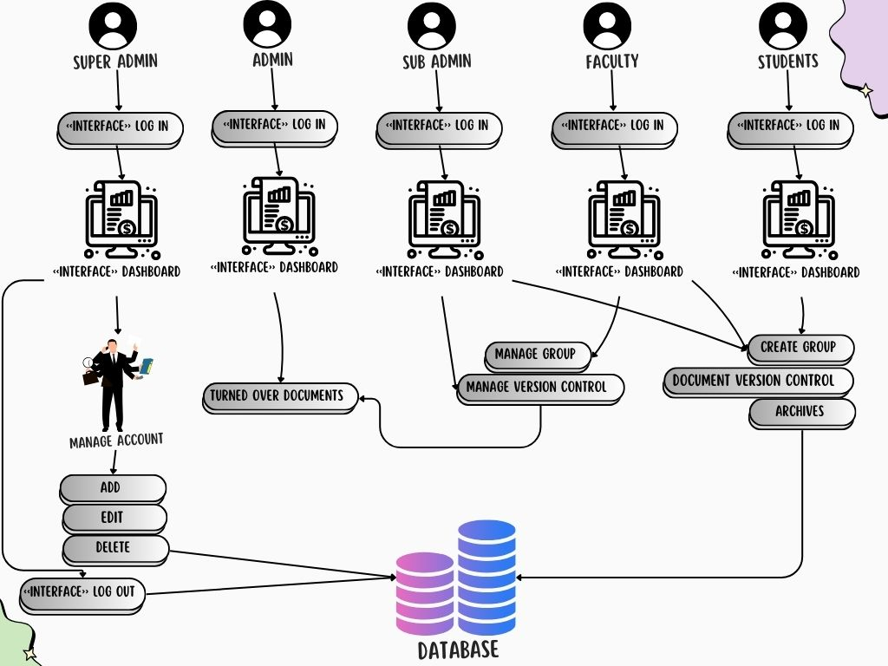****Figure 2.1 Concept Map of a Secure and User-Friendly Archiving System***

How the system will operate, and flow is shown in Figure 2.1. There are three tiers of users starting with the administrator, who manages all tasks like evaluating capstone projects, student accounts, and faculty accounts. Next is the faculty. They submit the students' final capstone projects and have access to see and search for them. The students come last. Students have access to files and read, search, and use the compatibility tester.

#### 

# Chapter 3

## METHODOLOGY

To ensure that developer efforts are organized and as successful as possible, it is imperative that the materials be of excellent quality and that the study strategy be explained in a precise and perfect way. This is an essential component of the research technique and includes requirements collecting, design, development, testing, deployment, and review, among other stages.

**3.1 Requirement Analysis**

The analysis of requirements is crucial to the success or failure of a system or software project. The requirements must be written, actionable, quantifiable, tested, traceable, relevant to identified business needs or opportunities, and detailed enough for system design. The process of defining user expectations for a new or improved application is known as requirements analysis (ReQtest,2020). It encompasses all tasks performed to determine the expectations of diverse stakeholders. As a result, "requirements analysis" refers to the process of analyzing, documenting, validating, and maintaining the requirements of software or systems. High-quality requirements are written, actionable, quantifiable, testable, and traceable, and they help identify business opportunities. The primary data source in identifying requirements is the first step in gathering information for Pangasinan State University. After gathering the necessary information, the developers investigated the system's problem. Developers create the user's requirements. The developers analyzed all the requirements essential to meet the desired idea for the system to be constructed.

### Hardware and Software Requirements

The developers meticulously detailed the hardware and software requirements that would meet the created system’s expectations. In software deployment, the disclosure of hardware and software requirements allows the system to perform as intended. The set of documents or documentation describing a system's behavior includes a variety of elements that try to define the intended functionality required by the stakeholder to satisfy their different users.

### Hardware Requirements for System Development

Hardware requirements are the statements of requirements that would identify and dictate the system's performance to satisfy clients and owners. Identifying the hardware requirements enables the system to provide its best performance and handle the processing of data (Siedle, 2020). The hardware requirements for the development of Thesis Corner: An online repository system from proposal to archivingare an important aspect.

***Table 3.1 Hardware Requirements***

|  |  |
| --- | --- |
| **Computer Hardware Components** | **Specification** |
| Display | 1280x720 |
| Processor | Intel core i3 |
| RAM | 8 GB |
| Hard Disk Drive | 125 GB (SSD) |
| Mouse / Keyboard | USB / Wireless |

### Software Requirements for System Development

This comprises various procedures and methodologies for achieving the target objection of the project. The method and steps presented will guide the developers in completing the input process and output phases for developing the THESIS CORNER: AN ONLINE REPOSITORY SYSTEM FROM PROPOSAL TO ARCHIVING.

***Table 3.2 System Development Software Requirements***

|  |  |
| --- | --- |
| **Computer Software Components** | **Specification** |
| Windows Operating System | Windows 10 |
| Database | MySQL |
| Programming Language | PHP /JavaScript / CSS / HTML |
| Web Browser | Google Chrome /Microsoft Edge – Latest versions / Brave |
| Framework | Laravel |

Software requirements are a set of documents that explain a software application's characteristics and behavior. It consists of a few numbers of aspects that seek to define the customer's intended functionality to satisfy their various consumers. To ensure smooth project development, every team member must understand the development process in the same way. This would define the features and behavior of the system or software application for commercial use (Inflecta, 2020).

#### 3.2 System Framework

The Scrum Agile Methodology, a framework for doing projects by allocating tasks into small stages called sprints, and Kanban, a scheduling system to manage the flow of work using visual signals. In this regard, both Methodology have been reviewed to investigate the similarities and differences between them. Then, a focus group survey was performed to specify the preferable methodology for product development according to various parameters in the project environment including project complexity, level of uncertainty, and work size with consideration of output factors like quality, productivity, and delivery. Results show the flexibility of both methodologies in approaching Agile objectives, where Scrum emphasizes the corporation of the customer and development teams with a focus on particular skills such as planning, organization, presentation, and reviewing which makes it ideal for new and complex projects where a regular involvement of the customer is required, whereas Kanban is more operative in continuous-flow environments with a steady approach toward a system improvement. The term "Scrum" comes from rugby and refers to how a game is restarted after a foul or when the ball is out of play. According to (Laoyan, 2022), Agile methodology is a project management framework that breaks projects down into several dynamic phases, commonly known as sprints. In this article, get a high-level overview of Agile project management, plus a few common frameworks to choose the right one for your team.

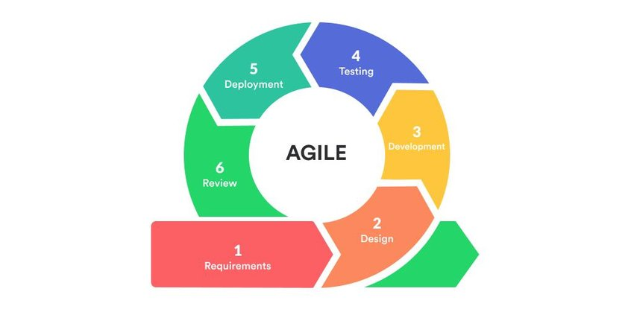

***Figure 3.0 Agile Methodology***

**Requirements**

The Agile requirements phase, such as functions, services, and features, are the key elements a product needs to include to be successful. Teams may develop agile requirements as business rules, functions, or constraints to guide them through the production process. The final product or service must pass the criteria for each agile requirement to meet the needs of its intended users (Indeed Editorial Team, 2023).

During the requirements phase, developers collect information on the internet about what an archiving system should have and what it should look like and build the requirements process based on the gathered information online and collaborate with stakeholders and users to gather project’s requirements.

**Design**

The Agile design phase is a highly collaborative way of designing and developing new products that break big tasks into groups of subtasks. These subtasks are executed in interactive, incremental cycles known as sprints. Its origins began with the agile software design process, but it has grown to have applications in any industry where the project requires a high level of customer engagement to provide the team with valuable feedback throughout the process and where teams need to solve critical issues instantly to avoid additional resources, both time and money, later in the process if not addressed early on (Jones, 2022).

During the design phase, the developers designed the back and front end of the archiving system that aligns with the project's requirements, ensuring that the solution is user-friendly.

**Development**

The Agile software phase development cycle relies on iterations or single development cycles that build upon each other and lead into the next step of the overall development process until the project is completed. Every iteration typically lasted between two to four weeks, with a set completion date. (Brush & Silverthorne, 2022).

During this phase, developers use a simple PHP framework for archiving web applications, normalizing the database, and developing an optimized backend based on the design and requirements.

**Testing**

The Agile Testing phase is a testing practice that follows the rules and principles of agile software development. Unlike the Waterfall method, Agile Testing can begin at the start of the project with continuous integration between development and testing (Hamilton, 2023). During the testing phase, web applications were tested by the developers, encompassing unit testing, integration testing, and user acceptance testing, to ensure they met the defined requirements and quality standards.

**Deployment**

The deployment phase is run after one or more evolutionary development phases to put the latest increment into production. Some projects have only one deployment at the end, some have a few deployments (e.g., one after every 5 iterations of development), and some deploy every iteration (Rad, 2023).

During this phase, the archiving system is being deployed locally and tested by the co-developers to find bugs. The deployment on the server or online domain occurred after the finalization of the system.

**Review**

#### Sprint reviews are not retrospectives. A sprint review is about demonstrating the challenging work of the entire team: designers, developers, and the product owner. At Atlassian, we like to keep our sprint reviews casual. Team members gather around a desk for informal demos and describe the work done for that iteration. (Radigan, 2023).

#### During this phase, developers collaborate with the stakeholders, users, and team to ask questions, try new features, and give feedback for improvement in the development process and delivering high-quality system. Sharing success is an important part of building an agile team.

#### 3.3 Tools for Data Analysis - Use Case, ERD, Data Dictionary

This area of the study discusses the different tools used for data analysis. It also includes the used case diagrams and entity relationship diagram models for the representation of the systems’ workflow.

**Data Analysis**

Important data are gathered primarily from the dean of the College of Hospitality Management Business and Computing of Pangasinan State University, San Carlos Campus. The respondents are result in randomly sampled to find them reliable in conducting usability tests. The identity of the respondents is not revealed for confidential purposes. The developers used different data-gathering instruments to acquire valuable and relevant information needed for the study. They utilized different methods to obtain the necessary information to complete the study.

**Document Analysis** - The focus of the analysis should be the critical examination, rather than the mere description of the documents. It is a social research method and is an important research tool in its right. Documentary work involves reading lots of written material.

Document analysis is a social research method and an important research tool. It is also an essential component of most triangulation schemes, which combine methodologies in the study of the same phenomenon (Bowen, 2019). The developers underwent a thorough analysis of the online appointment system and inventory, and management system documents were conducted, determining and identifying the needs and challenges of the current online veterinary management with the appointment system.

**Interview** – To avoid misinterpretation of the question, the questions should be asked as written for all respondents. For the same reason, clarification of the question should be avoided. However, if there is a misunderstanding, the questions can be repeated. The questions should be asked in the order specified in the questionnaire, as a specific question may not make sense if the questions preceding it are skipped. An interview is a formal encounter in which one or more people are questioned, discussed with, or evaluated by another individual to obtain background information (Malicdem, et. al,2019). The developers interviewed and discussed with the stakeholders and clients involved in the study to obtain the necessary data and information to support and strengthen the study. In addition, the interview gives the developers a better response rate than mailed questions, and the people who cannot read and write can also answer the questions.

**Internet Sources** – The internet has made researching a topic easier than ever before. People with internet access can simply pull up a search engine, type, and click away instead of going to the library. According to (Lumencandela, 2020), scholarly journals and databases are the most common sources of reliable, credible information on the Internet. These academic, peer-reviewed collections offer extensive reports, case studies, articles, and research studies to help you with your research. The developers used internet websites to gather relevant data and obtain current information and related articles relevant to online veterinary management with the appointment system. Many related studies are found on the internet which helped the developers to strengthen their points in developing the study.

**Survey –** the developers used surveys to gather information and avoid biased opinions that may affect the study's outcome. According to (Qualtrix, 2020), survey is a method of gathering information from a sample of people by asking relevant questions to understand populations. Surveys are an important source of data and insights for everyone involved in the information economy, from businesses to the media to government and academia. In the study, the survey is a research method used for collecting data from a predefined group of respondents to gain information and insights into several topics of interest. The data is obtained through standardized procedures to ensure that each respondent can answer the questions on a level-playing field to avoid biased opinions that could influence the research or study's outcome.

**Entity Related Diagram (ERD)**

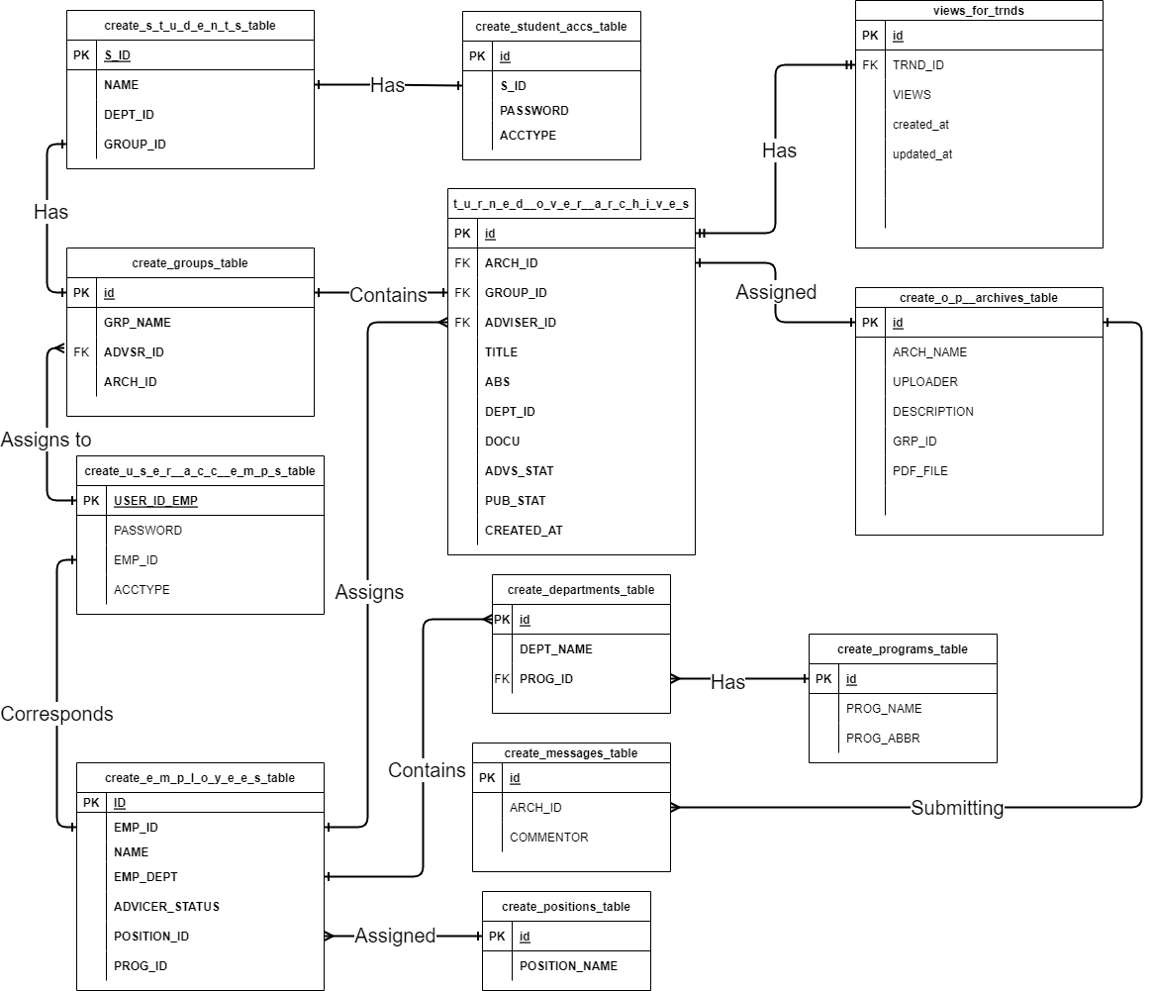

***Figure 3.1 Entity Relationship Diagram***

#### The Entity Relationship Diagram (ERD), also known as the ER Diagram or the ER model, is a structural diagram used in database architecture. An ERD contains several symbols and connectors that depict two crucial pieces of information: the major entities inside the system scope and their interrelationships.

**Use Case Diagram**

In Figure 3.2, the information and individuals involved in the developed system's processes are represented. The administrator assumes a vital role in the system, overseeing overall transactions and being responsible for various critical tasks. This includes the administrator's ability to log in, monitor sales, manage inventory, and ensure product control. The system also serves as a secure repository for records related to assets and crops. Additionally, an analytics feature aids the administrator in identifying trends in monthly and recent agricultural sales. Furthermore, the administrator can access and manipulate system information, allowing them to configure the system from the inside to the outside. The statement also introduces the use of a case diagram as a method for summarizing system details and interactions, noting that it specifies events and their flow but does not delve into event implementation.

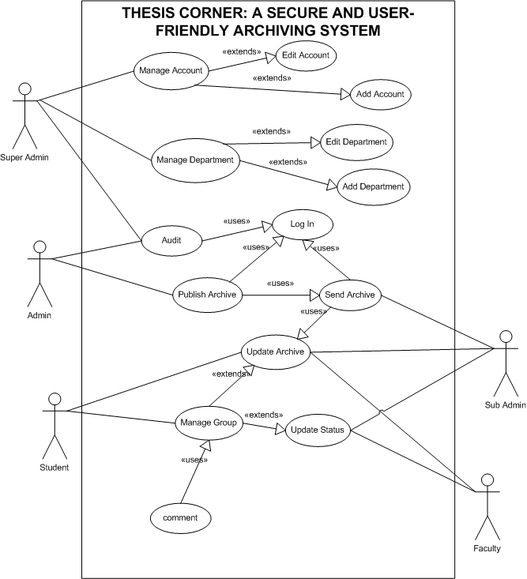***Figure 3.2 Use Case Diagram***

#### 3.4 Technical Background

The capstone project is a web application designed to assist the IT Department of Pangasinan State University. It primarily utilizes PHP (Hypertext Pre-processor), a widely popular server-side scripting language in web development. PHP is known for its simplicity and popularity, being used by major platforms like Facebook and Harvard University. It offers several advantages, including platform independence, open-source support, organized structure, free availability, database integration, ease of coding, and easy integration with web applications. JavaScript is also a crucial component, present on most websites, and it is a fundamental part of modern web development. JavaScript frameworks power many complex and interactive web applications, contributing to responsive design frameworks that enhance user-centric application development.

In the capstone project, the developers would develop a web application called THESIS CORNER: AN ONLINE REPOSITORY SYSTEM FROM PROPOSAL TO ARCHIVING, which would utilize Hypertext Pre-processor (PHP) as the programming language and JavaScript (JS) along with Cascading Style sheets (CSS) as the PHP framework. With the introduction of JS Framework and CSS Frameworks, developers can now extend the functionality of some applications. It provides a convenient interface and the capability to create a web application. It is embedded with a template engine, which is commonly used for the listing of fantastic web layouts for web applications that would help develop web applications. The list of these exceptional front-end web development frameworks is much more extensive than the others. The author managed to summarize the ones that are truly innovative in their features. They are easy to use and learn and help developers to scale the functionality of the applications. Technical solutions are used to select, design, and implement solutions to requirements. Solutions, designs, and implementations encompass products, product components, and product-related lifecycle processes either singly or in combination as appropriate (Wibas, 2021). Typically, these activities interactively support each other. Some level of design, at times detailed, can be needed to select solutions.

Prototypes or pilots could be used as a means of gaining sufficient knowledge to develop a technical data package or a complete set of requirements. Quality attribute models, simulations, prototypes, or pilots could have been used to provide additional information about the properties of potential design solutions to aid in the selection process. Simulations could have been particularly useful for projects developing systems-of-systems. The developers created a web-based application called Thesis Corner: An online repository system from proposal to archivingusing the PHP Framework (Laravel), HTML, CSS, JavaScript, jQuery, MySQL, and XAMPP. This archiving system with a title checker was developed using version 8.1 of PHP in Laravel version 10. The system might not have functioned well with older PHP versions, such as PHP version 5 and below. PHP version 8.1 could run the system without any problems because it was an up-to-date version of PHP that included numerous new features, improvements, and developments. Additionally, for its User Interface Design, developers used HTML and CSS for better lighting and design to ensure user satisfaction with each page. Furthermore, the use of HTML and CSS allowed for the creation of a user-friendly interface. Finally, developers also incorporated JavaScript and jQuery to add functionalities to the system. For the backend, developers utilized MySQL. XAMPP was used to enable offline website development using the local server. As for the Integrated Development Environment, programmers utilized Sublime Text software for application building and code editing.

**Software Used in the System**

Developers utilized different software applications and programs to develop the system. This said application is as follows:

**PHP.** PHP: Hypertext Pre-processor is a server-side scripting language. That is used to develop Static websites or Dynamic websites or Web applications. PHP stands for Hypertext Pre-processor, which earlier stood for Personal Home Pages (Jackson, 2023). The developers use PHP as their major programming language, particularly with the Laravel framework. This decision highlights PHP's strength in web development, where it offers scalability and flexibility for addressing difficult tasks.

**HTML**. The HTML Hypertext Markup Language is a text-based approach to describing how content contained within an HTML file is structured. This markup tells a web browser how to display text, images, and other forms of multimedia on a webpage (Lutkevich, 2023). It is essential for organizing the user interface of the system and delivering a smooth and simple experience. HTML helps in establishing a secure environment, together with Laravel. HTML's capacity to produce structured and clear web pages works in addition to Laravel's security capabilities.

**CSS**. Cascading Style Sheets is the language for describing the presentation of Web pages, including colors, layout, and fonts, thus making our web pages presentable to the users (Parvez, 2023). CSS is essential to Capstone Corner's layout and aesthetic appeal. It ensures that the interface is aesthetically pleasing, orderly, and user-friendly, all of which contribute to the archiving system's overall effectiveness.

**JavaScript**. JavaScript is an actively evolving language and has changed over the years. In particular, the 6th edition of the language (sometimes known as ECMAScript 2015 or ES6), introduced in 2015, added many new features. (Caraya, 2023). The Capstone Corner is made more interactive, dynamic, and user-friendly using JavaScript, which is necessary for adding interactivity. It was once utilized to implement multiple client-side features that improve the archiving system.

**MySQL**. MySQL is an Oracle-backed open-source relational database management system (RDBMS) Relational Database Management System based on Structured Query Language (SQL). MySQL runs on all platforms, including Linux, UNIX, and Windows. Although it can be used in a wide range of applications, MySQL is most often associated with web applications and online publishing (Moore, 2019). By operating as a database management system and improving the overall security and accessibility of the system, MySQL has a vital role in the technical accomplishment of the Thesis Corner.

**XAMPP.** Xampp is an application that is open source and is used for research. Using Xampp, programmers will build a local web server. Xampp is similarly compliant with Debian, Microsoft Windows, and Mac operating systems as well (Tawde, 2023).  XAMPP was helpful because it used to be implemented as part of Thesis Corner's technical setup to test the archiving system locally before deploying it to a live server, for instance, it used to build up a local server environment. <https://www.usability.gov/how-to-and-tools/methods/system-usability-scale.html>

**Laravel**. Laravel is a web application framework with expressive, elegant syntax. We have already laid out the developers used Laravel, the framework for creating the Capstone Corner is Laravel, and Laravel is used to create the system’s backend (server-side logic and database interactions) (Otwell, 2020). Thesis Corner's technical development has been significantly aided by Laravel, particularly in the creation of the backend infrastructure and the maintenance of the system's security and usability. Foundation freeing you to create without sweating the insignificant things

#### 3.5 Implementation Plan

The implementation plan describes how the information system will be deployed, installed, and transitioned into an operational system. The plan contains an overview of the system, a brief description of the major tasks involved in implementation, and the overall resources needed to support the implementation efforts. The plan is developed during the design phase and is updated during the development phase.

The implementation plan will also include a thorough risk assessment to identify potential challenges and develop contingency plans to mitigate any disruptions during deployment. Additionally, scalability and future-proofing measures will be incorporated to ensure that the Thesis Corner system can accommodate growth in data volume and technological advancements over time. Continuous monitoring and evaluation post-implementation will be carried out to assess system performance, gather user feedback, and make iterative improvements as necessary, aligning with the university's commitment to ongoing excellence in digital archiving and academic support.

***Table 3.5 Implementation Plan***

|  |  |  |  |
| --- | --- | --- | --- |
| **STRATEGY** | **ACTIVITIES** | **PERSONS INVOLVED** | **DURATION** |
| Approval from the PSU SC Bachelor of Science in Information Technology Dean | Letter of Approval from the Researchers | Researchers, IT Faculties, and CHMBAC Dean | 3 Weeks |
| System’s Implementation | Installation of the system and required software and hardware | Researchers, Faculties | 5 Hours |
| Information Distribution | System Manuals | Researchers, Information Technology Department Dean, | 1 Day |
| 1 Day Training | Training and Lectures of System Users | Researchers, Administrators, IT Faculty, CHMBAC Dean, | 1 Day |

#### 

#### 3.6 Statistical Tool

Statistics is the study and practice of advancing human knowledge through quantitative analysis of empirical data. It is based on statistical theory, which is an application of mathematics. Statistical tools are purposively made or used for data collection and analysis in research methodology. Statistical tools are purposively made or used for data collection and analysis in research methodology. The developers used weighted arithmetic means to determine the average response for each item of the five (5) options in each item in the questionnaires namely, 5 (Strongly Agree), 4 (Agree), 3 (Neutral), 2 (Disagree), 1 (Strongly Disagree).

The following is the mathematical formula for the weighted arithmetic mean.

|  |  |
| --- | --- |
| Where: | 𝑊(𝑎𝑣𝑒) = weighted mean |
| 𝑊𝑖 | = weight of frequency of each option |
| 𝑋𝑖 | = value of each option |
| 𝑁𝑖 | = the number of respondents |

***Table 3.4 Scales and Points in the Instrument***

|  |  |
| --- | --- |
| **Scale** | **Points** |
| Strongly Agree | 5 |
| Agree | 4 |
| Neutral | 3 |
| Disagree | 2 |
| Strongly Disagree | 1 |

Table 3.4 shows the scales and points used in the acceptability test conducted on the system. It demonstrated that 5 points is equivalent to strongly agreeing with the questions being asked, 4 point is equivalent to agreeing on the questions being asked, 3 points is equal to being neutral on the questions being asked, 2 points is equivalent to disagree on the questions being asked, and lastly, 1 point is equivalent to strongly disagree on the question being asked.

**3.7 Network Diagram**

The system developed is based on the functional and non-functional requirements identified by the developers. The identification of those requirements is based on the strict principles of validity. Developers gathered information that would be utilized in developing the system framework.

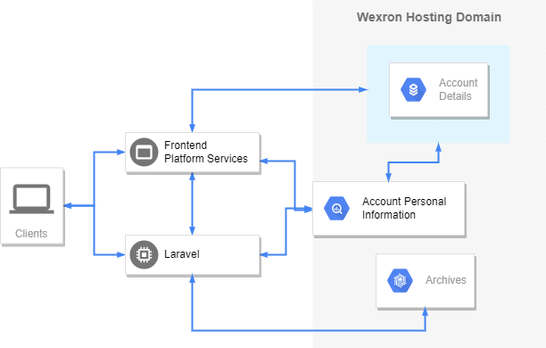The Thesis Corner system at Pangasinan State University, San Carlos City, offers a streamlined approach to archiving capstone projects, managing user accounts, and ensuring compatibility checks for titles. The admin's role is crucial in overseeing account management for both faculty and students, ensuring smooth operations and access control. Additionally, the compatibility checker feature serves as a valuable tool for all users, helping them avoid duplication of research efforts and ensuring originality in their work.

***Figure 3.3 Web Network Diagram***

Furthermore, the system's procedure encompasses various stages such as development and coding, quality assurance, testing, and eventual implementation. Each of these stages is meticulously planned and executed to ensure the system's functionality, reliability, and security. The web network diagram provides a visual representation of the system's flow, highlighting key interactions and processes involved, although it doesn't delve into the intricate details of each operation but rather offers an overview of the system's operational flow.

# 

# Chapter 4

## RESULTS AND DISCUSSION

This chapter discussed the following findings of the study. This area tackled how the system was planned and implemented and discussed the findings of the conducted acceptability test of the system. It also tackled the user requirements, engineering requirements, and manual processes of the system, as well as the functional and non-functional requirements implementation.

**Findings and Analysis of the System**

The study’s findings were discussed in this section. They go over the manual services process, the implementation of functional and non-functional requirements, and the results of the system acceptability test. To appropriately convey and explain the system’s output and findings, developers used several tables and graphs.

**4.1 The existing Process of the Capstone and Thesis of Pangasinan State University San Carlos Campus.**

From the very earliest days of electronic computing, flowcharts have been used to represent the conceptual structure of complex software systems. In much of the literature on software development, the flowchart serves as the central design document around which systems analysts, computer programmers, and end users communicate, negotiate, and represent complexity (Ensmenger, 2019).

A flowchart is a picture of the separate steps of a process in sequential order. It is a generic tool that can be adapted for various purposes and can be used to describe various processes, such as manufacturing, administrative or service, or project planning. Below is the manual process of Pangasinan State university San Carlos Campus final projects.

***Figure 4.1. Existing Process of the Capstone and Thesis***

Figure 4.1.1 discusses the flowchart of the existing process of the capstone and thesis of the Pangasinan State University San Carlos Campus. The students will be proposing their title first. When the proposal is approved, a specific advisor will notify the group, and then the students will defend it. When the proposal is approved, students will persist in the development. When the students finish the document, complete the documentation and system, then students will defend it, and then the group needs to submit the hard.

**4.2 Functional Features of the System**

This section provides a detailed overview of the system's capabilities, specifically focusing on efficiently managing final project information and offering robust archiving functionalities. The archiving feature securely stores and organizes project documents, data, and communications. Users can categorize files based on criteria like project phase, document type, or date for easy retrieval. Additionally, version control ensures that archived documents are constantly updated with the latest revisions.

The Student Registration Form shown in figure 4.2.1 within our Archiving Management System is pivotal in efficiently onboarding and organizing student information. This feature is designed to simplify capturing essential details about each student enrolled in our educational institution. This form creates comprehensive profiles for every student, encompassing fundamental personal information such as name, school ID, course, and password. The Student Registration Form is the cornerstone for effective student management within our educational institution, streamlining administrative processes and fostering personalized support for student success.

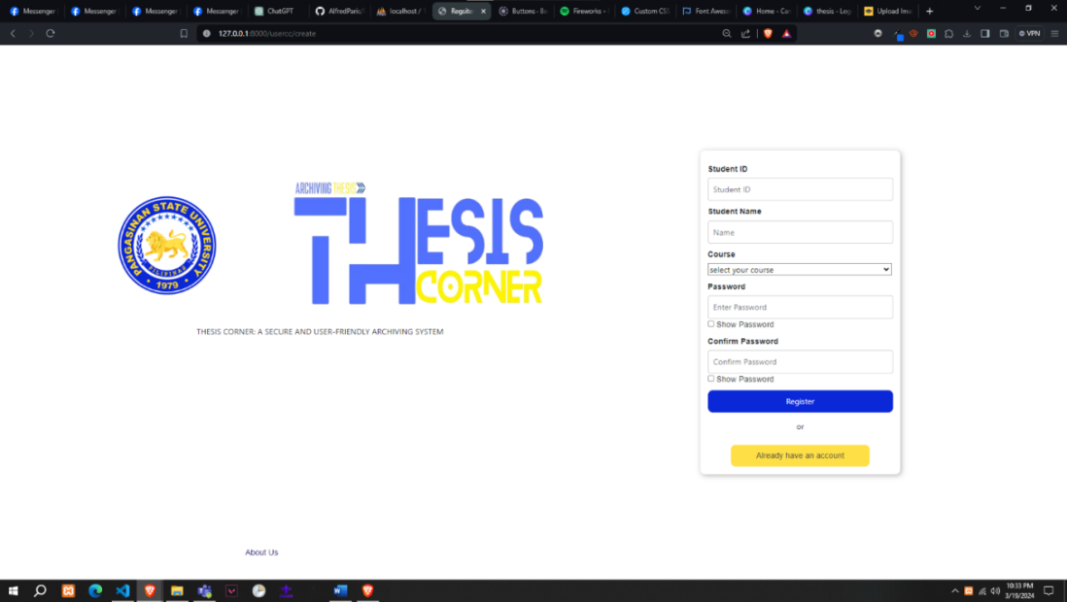

***Feature 4.2.1 Student Registration Form (All Users)***.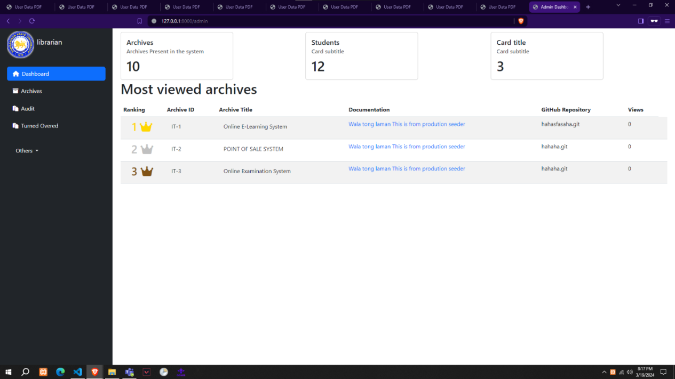***Feature 4.2. 2 Dashboard Page (All Users)***

The Dashboard Page shown in figure 4.2.2 is the central hub of our system, providing users with a comprehensive overview of key metrics and important information. Designed to be intuitive and user-friendly, it serves as a one-stop destination for accessing vital data and tracking the performance of published archives within our platform. At the forefront of the Dashboard Page is the display of total published archives, providing users with real-time insight into the content volume available for viewing. This metric serves as a barometer of the platform's activity and highlights the richness of our archive collection. Additionally, the Dashboard Page features a dynamic section showcasing the top archives that have garnered the most views. By highlighting these standout archives, users can quickly identify popular and trending content within our platform. It not only facilitates discovery for users seeking valuable information but also provides content creators with valuable feedback on the effectiveness of their submissions.

***Feature 4.2.3 Group Page (Advisers and Students)***

In Figure 4.2.3, the student group's appointment of an advisor tasked with overseeing and maintaining the group's archives introduces a structured approach to record-keeping and document management. By entrusting this responsibility to a designated individual, the group ensures continuity and consistency in archival practices, safeguarding important information for future reference. Additionally, the system's feature allowing the advisor to make comments on current documents fosters seamless communication and collaboration within the group. This interactive capability facilitates ongoing dialogue, idea-sharing, and feedback loops, ultimately strengthening teamwork and enhancing productivity. With a well-organized archive and streamlined communication channels, the group can effectively navigate projects, initiatives, and decision-making processes with clarity and efficiency.

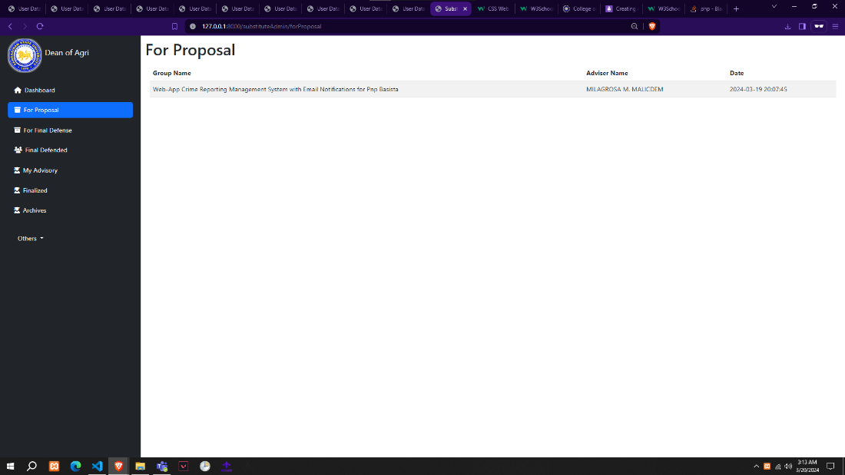***Feature 4.2.4 For Proposal Groups (Sub-Admin)***

The sub-admin shown in figure 4.2.4, is the receiver of the final documents of the thesis. Sub-administrators are essential to the operation and usability of the archiving system within their designated aspects of impact, even though they might have partial administrative authority over the super admin.

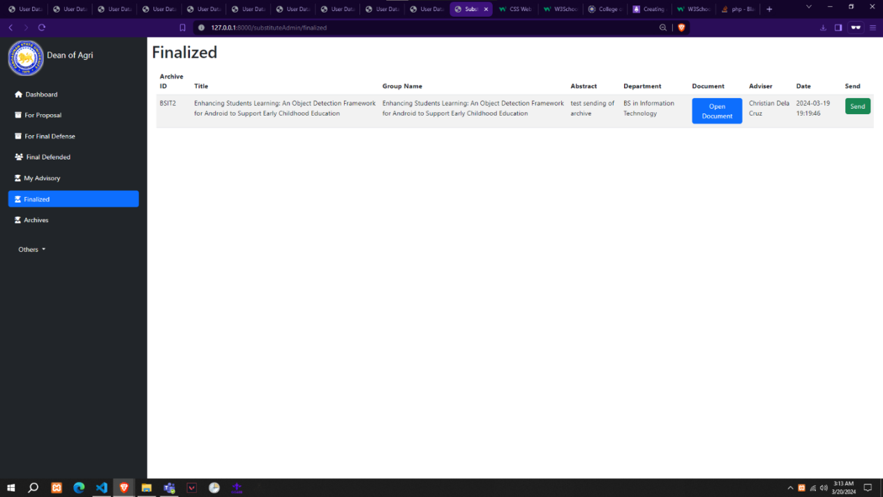

**Feature 4.2.5 Finalized Archives (Sub-Admin)**

In Figure 4.2.5, the Finalized archive page is exclusively for substitute administrators like Deans and Chairpersons. It's a secure space for them to review and manage important documents, ensuring confidentiality and efficient administrative processes.

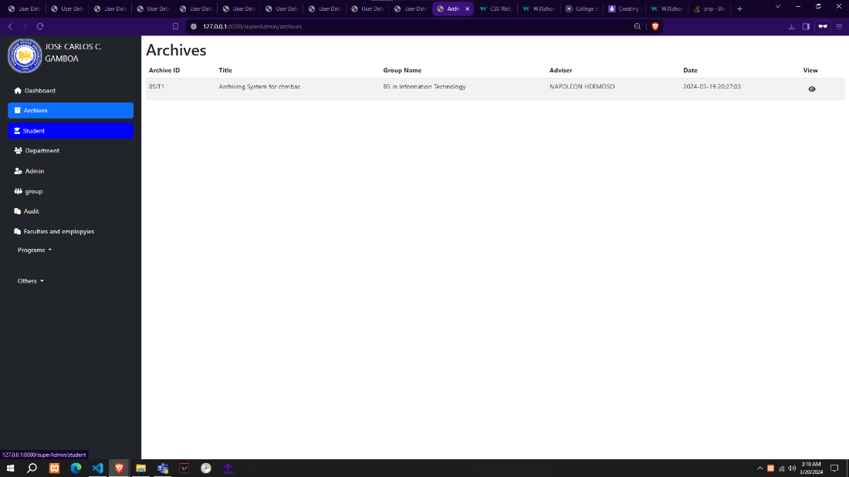***Feature 4.2.6 Published Archives (All Users)***

The super admin shown in figure 4.2.4, is essential to maintaining the security and efficient operation of the archiving system. To ensure standards are followed, they manage the arrangement of material and manage user accounts, including access rights. They also set up security measures, configure system settings and secure data. Their duties include producing reports, monitoring system performance, and offering technical assistance. The super admin makes sure the system keeps its integrity and runs properly.

**4.3 Non-Functional Features**

Archiving in software implementation requires non-functional features such as scalability, performance, security, and compliance. Scalability handles growing data efficiently, while performance ensures fast and responsive archiving. Security protects data from unauthorized access and compliance ensures adherence to regulations. These features are vital for effective archiving, ensuring data management, protection, and regulatory compliance.

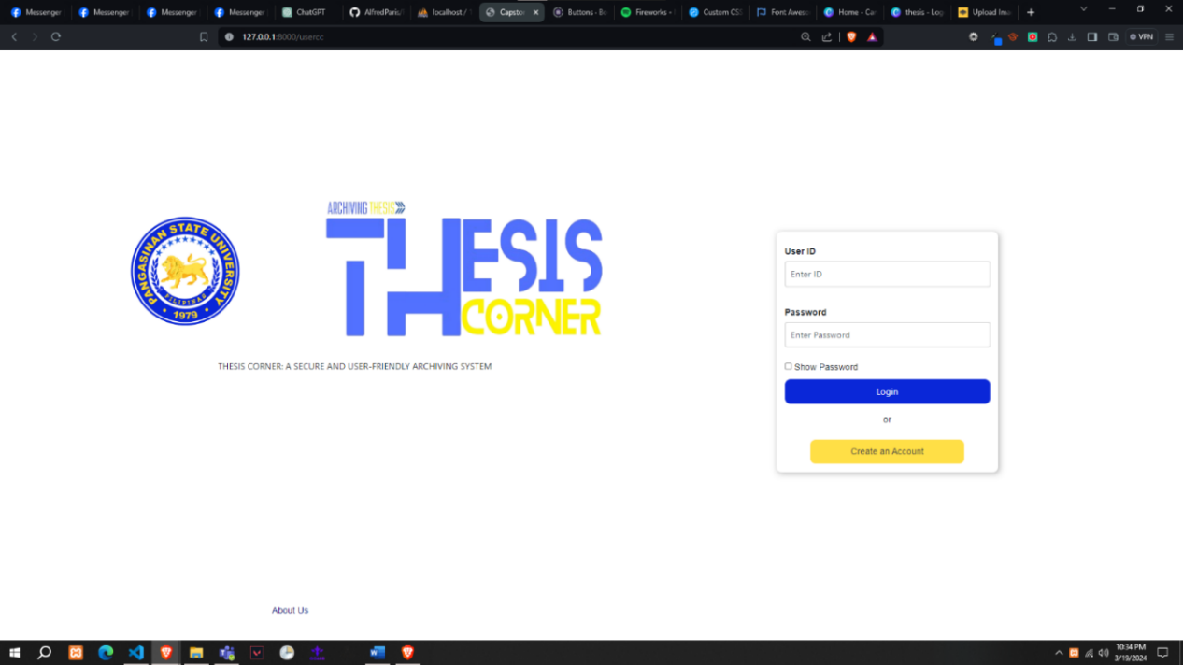**Feature 4.3.1 Log In Page (All Users)**

The Login Form shown in figure 4.3.1, is a fundamental system component, providing secure access to authorized users. Designed with simplicity and security, it is a gateway for users to access our platform's various functionalities and resources.

Through the Login Form, users with valid credentials can securely authenticate themselves and gain access to their personalized accounts. Ensures authorized individuals can interact with sensitive data and perform actions within the system.

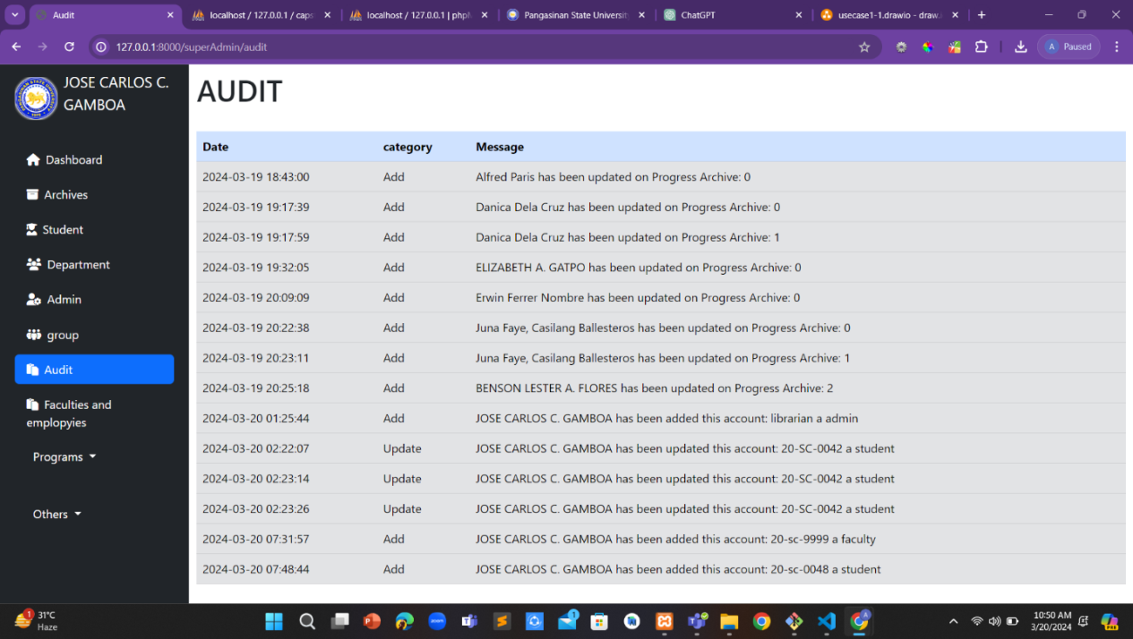**Feature 4.3.2 Audit Page (Admin and Super Admin)**

The Audit Page shown in figure 4.3.2, may generate comprehensive reports or summaries of user activities, facilitating regulatory compliance audits and internal reviews. These reports serve as invaluable resources for demonstrating adherence to data governance standards and bolstering the overall trust and confidence in our system. In summary, the Audit Page stands as a cornerstone of governance and accountability within our platform, providing administrators and super administrators with the insights and tools needed to uphold the highest standards of integrity, security, and compliance.

**4.4 Acceptability Test of the System**

The goal is to check whether the system meets the specified requirements. Acceptance testing is the type of testing that is used to check whether the system meets user satisfaction. Stakeholders and respondents use it. Through hands-on interaction with the system, stakeholders evaluate its usability, intuitiveness, and effectiveness in meeting their specific needs and requirements. This examination of the system by stakeholders during acceptability testing includes an assessment of its features, functionalities, and overall performance.

**Learnability.** Learnability is the probability that a system performs correctly during a specific time. During this correct operation, no repair is required or performed. The system adequately follows the defined performance specifications.

***Table 4.4.4 Learnability***

|  |  |  |
| --- | --- | --- |
| **Learnability** | **WM** | **Descriptive Rating** |
| 1. Using the system for the first time is easy. | **4.10** | **Satisfied** |
| 2. Remembering where I am on this system is not difficult. | **3.92** | **Satisfied** |
| 3. Learning to find my way around this system is not a problem. | **3.96** | **Satisfied** |
| 4. This system doesn’t need more introductory explanations. | **3.90** | **Satisfied** |
| 5. The interface of this system is pleasant. | **3.95** | **Satisfied** |
| LEGEND: 5-4.51-5.00: Very Satisfied; 4-3.51-4.50: Satisfied; 3-2.51-3.50: Neutral; 2-1.51-2.50: dissatisfied; 1-1.50 and below: Very Dissatisfied | | |

The table 4.4.4 It shows that most respondents are Satisfied, with the highest range of 4.10, saying that the system is high-speed, and with the lowest range of 3.90, saying that they expect when they click the system. It resulted in a total weighted mean of 3.97, rated as “Satisfied,” which responded to the respondents.

**Security.** Security is the probability that a system performs correctly during a specific time. During this correct operation, no repair is required or performed. The system adequately follows the defined performance specifications.

Table 4.4.4 shows that most of the respondents are Satisfied, with the highest range of 4.01, saying that they are Satisfied that the system is high-speed, and with the lowest range of 3.89, saying that they expect when they click the system. It resulted in a total weighted mean of 3.93, rated as “Satisfied,” which responded to the respondents.

***Table 4.4.4 Security***

|  |  |  |
| --- | --- | --- |
| **Security** | **WM** | **Descriptive Rating** |
| 1. How confident are you that your data is secure while using CAPSTONE CORNER? | **3.97** | **Satisfied** |
| 2. How satisfied are you with the security features of CAPSTONE CORNER? | **3.91** | **Satisfied** |
| 3. How satisfied are you with the security measures taken to protect your data in CAPSTONE CORNER? | **3.89** | **Satisfied** |
| 4. How comfortable are you with the types of data CAPSTONE CORNER collects about you? | **4.01** | **Satisfied** |
| 5. How confident are you that your Information is safe from cyber-attacks and resistant to malicious behavior? | **3.89** | **Satisfied** |
| LEGEND: 5-4.51-5.00: Very Satisfied; 4-3.51-4.50: Satisfied; 3-2.51-3.50: Neutral; 2-1.51-2.50: dissatisfied; 1-1.50 and below: Very Dissatisfied | | |

**User Satisfaction.** User Satisfaction is the probability that a system performs correctly during a specific time duration. During this correct operation: No repair is required or performed. The system adequately follows the defined performance specifications.

***Table 4.4.4 User Satisfaction***

|  |  |  |
| --- | --- | --- |
| **User Satisfaction** | **WM** | **Descriptive Rating** |
| 1. How satisfied are you with the accessibility of your archived data through Capstone Corner? | **4.01** | **Satisfied** |
| 2. How likely are you to recommend Capstone Corner: An online repository system from proposal to archivingto a friend or colleague? | **3.92** | **Satisfied** |
| 3. How user-friendly do you find the interface of Capstone Corner: A Secure and User-Friendly Archiving System? | **4.00** | **Satisfied** |
| 4. How satisfied are you with the security features provided by Capstone Corner: A Secure and User-Friendly Archiving System? | **3.9** | **Satisfied** |
| 5. How satisfied are you with the performance speed of Capstone Corner: A Secure and User-Friendly Archiving System? | **4.07** | **Satisfied** |
| LEGEND: 5-4.51-5.00: Very Satisfied; 4-3.51-4.50: Satisfied; 3-2.51-3.50: Neutral; 2-1.51-2.50: dissatisfied; 1-1.50 and below: Very Dissatisfied | | |

Table 4.4.4 shows that most of the respondents are Satisfied, with the highest range of 4.01 saying that they are Satisfied that the system is high-speed and the lowest range of 3.79 saying that they expect when they click the system. It resulted in a total weighted mean of 3.96, rated as “Satisfied,” which responded to the respondents.

**Efficiency of use.** Efficiency of use is the probability that a system performs correctly during a specific time duration. During this correct operation: No repair is required or performed. The system adequately follows the defined performance specifications.

***Table 4.4.4 Efficiency of use***

|  |  |  |
| --- | --- | --- |
| **Efficiency of use** | **WM** | **Descriptive Rating** |
| 1. How would you rate the speed and responsiveness of Capstone Corner in accessing and retrieving archived data? | **4.05** | **Satisfied** |
| 2. How content are you with the response time when performing actions such as opening files or executing commands within Capstone Corner? | **3.98** | **Satisfied** |
| 3. How would you rate the efficiency of Capstone Corner in helping you accomplish your archiving tasks effectively and promptly? | **3.97** | **Satisfied** |
| 4. How likely are you to continue using Capstone Corner in the future? | **4.00** | **Satisfied** |
| 5. Indicate how likely you are to continue using Capstone Corner in the future. | **3.84** | **Satisfied** |
| LEGEND: 5-4.51-5.00: Very Satisfied; 4-3.51-4.50: Satisfied; 3-2.51-3.50: Neutral; 2-1.51-2.50: dissatisfied; 1-1.50 and below: Very Dissatisfied | | |

Table 4.4.4 shows that most of the respondents are satisfied with the highest range of 4.05 and say that they are Satisfied that the system is high-speed, and the lowest range of 3.84 says that they expect when they click the system. It has a result of a total weighted mean of 3.97, rated as “3.97,” according to the respondents.

**Usability.** Usability is the probability that a system performs correctly during a specific time duration. During this correct operation: No repair is required or performed. The system adequately follows the defined performance specifications.

***Table 4.4.4 Usability***

|  |  |  |
| --- | --- | --- |
| **Security** | **WM** | **Descriptive Rating** |
| 1. How satisfied are you with the effectiveness and efficiency of the main features offered by CAPSTONE CORNER? | **4.03** | **Satisfied** |
| 2. How would you rate the responsiveness and speed of CAPSTONE CORNER in meeting your interactions and requests? | **4.20** | **Satisfied** |
| 3. How does the system allow users to collaborate securely while preserving the integrity and privacy of data? | **4.22** | **Satisfied** |
| 4. How was the user experience improved at CAPSTONE CORNER through the iterative design process by integrating user feedback and usability testing? | **4.10** | **Satisfied** |
| 5. How would you describe the overall usability of CAPSTONE CORNER? | **4.20** | **Satisfied** |
| LEGEND: 5-4.51-5.00: Very Satisfied; 4-3.51-4.50: Satisfied; 3-2.51-3.50: Neutral; 2-1.51-2.50: dissatisfied; 1-1.50 and below: Very Dissatisfied | | |

The table 4.4.4 shows that most of the respondents are Satisfied with the highest range of 4.22 say that they are satisfied that he system are very fast and with the lowest range of 4.03 say that they expect when they click the system. It has a result of total weighted mean 4.15 rated as “Satisfied” which responded of the respondents.

***Table 4.4.5: Table for Overall Mean***

|  |  |  |
| --- | --- | --- |
| **Category** | **WM** | **Descriptive Rating** |
| **Learnability** | **3.97** | **Satisfied** |
| **Security** | **3.93** | **Satisfied** |
| **User Satisfaction** | **3.96** | **Satisfied** |
| **Efficiency of Use** | **3.97** | **Satisfied** |
| **Usability** | **4.15** | **Satisfied** |
| **Average Weighted Mean** | **4.00** | **Satisfied** |
| LEGEND: 5-4.51-5.00: Very Satisfied; 4-3.51-4.50: Satisfied; 3-2.51-3.50: Neutral; 2-1.51-2.50: dissatisfied; 1-1.50 and below: Very Dissatisfied | | |

Table 4.4.5 evaluates the Thesis Corner: An online repository system from proposal to archiving across various categories, their respective weighted means, and descriptive ratings. Learnability, representing the system's ease of learning, attained a weighted mean of 3.97, corresponding to a satisfied rating.' Security, indicating the system's security in usage, achieved a weighted mean of 3.93, resulting in a 'Satisfied' rating. Similarly, User Satisfaction garnered a weighted mean of 3.96, indicating a satisfactory level of user contentment with the system's performance. Efficiency of Use, indicating the system's efficiency in usage, achieved a weighted mean of 3.97, resulting in a 'Satisfied' rating. However, regarding usability, with a weighted mean of 4.15, the system received a rating of ' Satisfied'. The Overall Mean of 4.00 reflects a general satisfaction level with the system's performance across all evaluated categories. The results of an extensive survey that was carried out on Thesis Corner: A Safe and User-friendly Archiving System and included answers from 100 people on the Pangasinan State University San Carlos Campus. This capstone project's primary goal is to give a comprehensive awareness of campus demands and views of the system, which will help to improve the manual process of archiving thesis projects. The study aims to discover important information that will direct the system's functionality optimization, ultimately guaranteeing customized service delivery to satisfy the various needs of the Pangasinan State University San Carlos Campus.

# Chapter 5

## SUMMARY, CONCLUSIONS AND RECOMMENDATION

This chapter presents a summary and conclusions derived from the study, which aims to prove the effect of Thesis Corner: An online repository system from proposal to archivingon the Faculty, Third- and Fourth-Year students at Pangasinan State University San Carlos Campus. It also provides recommendations that the institution can pursue.

The study was conducted at Pangasinan State University San Carlos Campus. The respondents were the students from the different departments taking Capstone and thesis, Faculty, Department Chairpersons, and College Deans. They were selected using random sampling. It employed quantitative research and utilized experimental methods. Pertinent data were obtained through pretest and posttest. The statistical tools used were Mean and Percentage with the corresponding description.

**5.1 Summary**

The capstone project study aims to design and develop an Archiving System for Pangasinan State University San Carlos City Campus that would be a tool for the students from the different departments taking Capstone and thesis, Faculty, Department Chairpersons, and College Deans. To develop the Web-based application, the developers used PHP for the back end and HTML, CSS, and JavaScript for the front end. The developers used the requirements specification of the software tools as their basis for identifying the suitable hardware tool to be utilized. The areas that have been found to require improvement such as raising user satisfaction, strengthening system dependability, and adding more security measures will be the main focus. These improvements will be prioritized and applied iteratively using the Agile Scrum framework to ensure the system adapts to its stakeholders' and users' changing requirements and expectations. The goal is still to provide Pangasinan State University San Carlos Campus with An online repository system from proposal to archivingthat efficiently performs its intended function through continued cooperation and inputs.

The developers surveyed to measure the usefulness and acceptability of the developed system entitled THESIS CORNER: AN ONLINE REPOSITORY SYSTEM FROM PROPOSAL TO ARCHIVING. Then, the survey results will be evaluated using the data provided by the respondents.

The statement below is the findings about the developed system.

Based on the survey results, the system's "Learnability" has a weighted average mean of 3.97 with the interpretation of "Satisfied". It indicates the system's learnability is to learn and meet the objectives.

The "Security" of the system has a weighted average mean of "3.93" with the interpretation of "satisfied". It signifies that the system's security is acceptable.

User Satisfaction has a weighted average of 3.96, with an interpretation of "satisfied" based on the research conducted. This means the system's user satisfaction is met the user's satisfaction.

"Efficiency of Use" has a weighted mean of 3.97, with the interpretation of "Satisfied" based on the survey, which means that the system's efficiency is Acceptable.

Usability has a weighted average of 4.15 with an interpretation of "Satisfied" based on the research conducted. This means the system is valuable and acceptable. The overall system has a weighted average of 4.00, with an interpretation of "Satisfied" that meets the required approval for the system.

**5.2 Conclusions**

According to the findings of our capstone project study, students proposing the same title and content, we encountered a problem with students proposing the same title and content. The Thesis Corner: An online repository system from proposal to archivingfor Pangasinan State University San Carlos Campus will help the students archive their capstone and thesis. The Librarian manages the theses stored in libraries and organizes and sets up these theses so that users can access them.

The system adopts a user-friendly control interface, and using an easy word allows the user to operate the system without doubts and difficulties. Opening the source code and documentation will make future enhancements and improvements easier.

1. The students will propose their title first to identify the existing process of archiving the capstone project in the Pangasinan State University San Carlos Campus. When the proposal is approved, a specific advisor will notify the group, and then the students will defend it. When the proposal is approved, students will persist in the development. When the students finish the document, complete the documentation and system, then students will defend it, and then the group needs to submit the hardbound.
2. The features of Thesis Corner, A Secure and User-friendly Archiving System, have also been included in this study. To support this, in Chapter 4 or Appendices D., we discussed and provided screenshots of the specific features of the Archiving System for Pangasinsan State University San Carlos Campus like the Home page, login and Register page, Super Admin, Admin page, Student page, etc.
3. The implemented archiving system for Pangasinsan State University San Carlos Campus is given that system should be implemented by getting respondents to use the developed website together with the stakeholders of the study.
4. Lastly, the test of the system's acceptability is also needed. The developers created a questionnaire survey to gather the data of each respondent who uses the website. They also used a Likert scale, to sum up all the data gathered by determining their meaning and interpreting it. Learnability, Efficiency to Use, User Satisfaction, Usability, and Security: the developers calculated the mean, and all the respondents were satisfied; we concluded that the website was acceptable.

**5.3 Recommendations**

Recommendations indicate what future developers should do to improve its effectiveness reasonably and logically. Furthermore, the recommendations reflect how the project is used and its importance to users.

Developers presented the recommendation to the concerned with developing the outline of the Archiving System for Pangasinan State University San Carlos Campus. We provided project recommendations based on the findings of our capstone project study.

The goal of the archiving system for Pangasinan State University San Carlos Campus was to improve the manual process of archiving capstone and thesis projects By introducing a web-based system that simplifies the submission, storage, and retrieval of thesis project, Thesis Corner: An online repository system from proposal to archiving for Pangasinan State University San Carlos Campus aims to enhance the manual process of archiving capstone and thesis projects. With this system, instructors and students can track projects more effectively, and essential research outputs will be secure and preserved for future studies and references. The recommendations for the project and future development of the Archiving System for Pangasinan State University San Carlos Campus are as follows.

1. The system must provide a backup for the file to avoid data loss.
2. The developed Thesis Corner: An online repository system from proposal to archiving enhances their existing process and improves the system and security of a database.
3. A user-friendly interface allows the user students to upload files, create groups, and document version control since it will help the adviser give more proper advice.

# 

# References

Malak, H. A. (2023). What is Digital Archiving? Why is it Important? *Information Management Simplified,* Retrieved September 26, 2023, from [https://theecmconsultant.com/digital-archiving/](https://link.springer.com/article/10.1007/s42803-021-00040-5)

The Deployment Phase: AgilePM® wiki (2023). *AgilePM® Wiki,* Retrieved September 25, 2023, from <https://agilepm.wiki/dsdm-agile-project-framework/process/phases/deployment/>

Department of Health and Human Services (2023). System Usability Scale (SUS). *Usability.gov*, Retrieved September 22, 2023, from

[https://www.usability.gov/how-to-and-tools/methods/system-usability-scale.html#:~:text=Based%20on%20research%2C%20a%20SUS,to%20produce%20a%20percentile%20ranking](https://ejournals.ph/article.php#:~:text=Based%20on%20research%2C%20a%20SUS,to%20produce%20a%20percentile%20ranking).

Hamilton, T. (2023), What is Agile Testing. *Process & Life Cycle*. Retrieved September 21, 2023, from <https://www.guru99.com/agile-testing-a-beginner-s-guide.htmlDeployment>

Radigan, B. D. (2023), Three steps for better sprint reviews with your agile team.

*Agile sprint review*, Retrieved September 21, 2023, from[https://www.atlassian.com/agile/scrum/sprint-reviews](https://www.techtarget.com/searchsoftwarequality/definition/agile-software-development)

Sean Peek (2023), What is agile scrum methodology? *Business NewsDaily,*

Retrieved September 22, 2023, from https://www.businessnewsdaily.com/4987-what-is-agile-scrum-methodology.html

Businessnewsdaily.com, (2023). What is agile scrum methodology? *Business News Daily*. <https://www.businessnewsdaily.com/4987-what-is-agile-scrum-methodology.html>

Tprestianni (2023). What is a capstone project? *National University*.

Retrieved September 21, 2023, from

<https://www.nu.edu/blog/what-is-a-capstone-project/>

Patil, B. A. (2023). *10 Reasons Why Laravel Is the Best PHP Framework For 2023*.

Retrieved September 21, 2023, from [https://www.clariontech.com/blog/10-reasons-why-laravel-is-the-best-php-framework-for-2019#:~:text=Laravel%20is%20PHP%20web%20application,web%20applications%](https://doi.org/10.1177/0263276406023002106#:~:text=Laravel%20is%20PHP%20web%20application,web%20applications%)

20uickly%20and%20efficiently.

Indeed, Editorial Team (2023), What are agile requirements? *Agile Requirements: A Definitive Guide (With Benefits),* Retrieved September 21, 2023, from <https://www.indeed.com/career-advice/career-development/agile-requirements#:~:text=What%20are%20agile%20requirements%3F,them%20through%20the%20production%20process>

Jackson (2023). PHP, Retrieved October 2, 2023, from https://www.guru99.com/what-is-php-first-php-program.html

Lutkevich (2023). HTML, Retrieved October 2, 2023, from https://www.theserverside.com/definition/HTML-Hypertext-Markup-Language

Parvez (2023). CSS, Retrieved October 2, 2023, from https://www.mygreatlearning.com/blog/css-tutorial/

Caraya (2023). JavaScript, Retrieved October 2, 2023, from https://developer.mozilla.org/en-US/docs/Learn/JavaScript

Brush, K., & Silverthorne, V. (2022). Agile software development. *Software Quality.* Retrieved September 21, 2023, from

[https://www.techtarget.com/searchsoftwarequality/definition/agile-software-development#:~:text=The%20Agile%20software%20development%20cycle%20relies%20on%20iterations%20%2D%2D%20or,with%20a%20set%20completion%20date](https://netpreserve.org/projects/game-walkthroughs/#:~:text=The%20Agile%20software%20development%20cycle%20relies%20on%20iterations%20%2D%2D%20or,with%20a%20set%20completion%20date)

Nelson, M.L. and Cruz, K. (2022), Game Walkthroughs and Web Archiving. *International Internet Preservation Consortium*. Retrieved September 19, 2023, from [https://netpreserve.org/projects/game-walkthroughs/?fbclid=IwAR2D_PWYG5pu1C20exf37W0jOJUTiFdv6iNJQHlFf8gdSAfS_rtLf6T5D9w](https://www.clariontech.com/blog/10-reasons-why-laravel-is-the-best-php-framework-for-2019?fbclid=IwAR2D_PWYG5pu1C20exf37W0jOJUTiFdv6iNJQHlFf8gdSAfS_rtLf6T5D9w)

Ayala, B. R., (2022), Correspondence as the primary measure of information quality for web archives: a human-centered grounded theory study*. International Journal on Digital Libraries.* 23(1), Pp 19-31. Retrieved September 22, 2023, from <https://doi.org/10.1007/s00799-021-00314-x>

Yves Maurer (2022), Investigate holdings of web archives through summaries: cdx-summarize. *Web Archiving technical lead at the National Library of Luxembourg*. Retrieved September 21, 2023, from [https://netpreserveblog.wordpress.com/2022/08/10/investigate-holdings-of-web-archives-through-summaries-cdx-summarize/?fbclid=IwAR0xgV2lsQXv2LR1dSLuG9NXDtA42tP0d451IuJv9ISKsGLjtE9QGbVsSDc](https://asana.com/resources/agile-methodology?fbclid=IwAR0xgV2lsQXv2LR1dSLuG9NXDtA42tP0d451IuJv9ISKsGLjtE9QGbVsSDc)

Jalli, A. (2022). What is Laravel? *Built-In*. Retrieved September 21, 2023, from

<https://builtin.com/software-engineering-perspectives/laravel>

Sarah L. (2022). What is Agile methodology? (A beginner’s guide), *Summary.* Retrieved September 21, 2023, from [https://asana.com/resources/agile-methodology](https://www.kashipara.com/project/php/7325/online-thesis-archiving-system)

Joanne Jones (2022), What is Agile Design? *Agile Design: Process & Uses,* Retrieved September 21, 2023, from https://study.com/learn/lesson/agile-design-process-importance-steps.html#:~:text=Agile%20design%20is%20a%20highly,incremental%20cycles%20known%20as%20sprints.

Itsourcecode. (2021). Thesis online Archiving system using PHP. *Itsourcecode.com.* [https://itsourcecode.com/free-projects/php-project/thesis-online-archiving-system-using-php/?expand_article=1](https://doi.org/10.1142/S0219877020300025?expand_article=1)

iNetTutor.com. (2021), Thesis Archiving Management System Database Design*. iNetTutor.com Online Programming Lessons, Tutorials and Capstone Project guide,* Retrieved September 21, 2023, from <https://www.inettutor.com/source-code/thesis-archiving-management-system-database-design/>

Froilan D. Mobo (2021), The Development of an Online Database for Historical Archiving of Primary Sources. *International Journal of Multidisciplinary: Applied Business and Education Research*, 2 (3). Retrieved September 21, 2023, from

[https://ejournals.ph/article.php?id=16774&fbclid=IwAR2A3qzt1LXZVYpKyAIMlopazlPYDyFoU6aiE3yak6jD_QK-31_R1gt_hjI](https://link.springer.com/chapter/10.1007/978-981-13-1328-8_69?id=16774&fbclid=IwAR2A3qzt1LXZVYpKyAIMlopazlPYDyFoU6aiE3yak6jD_QK-31_R1gt_hjI)

Barat, A., Abdullayev, A. (2021). Analysis of the Main Trends and Directions of Automation in the Formation of the “Smart Archives” System. Retrieved September 21, 2023, from <https://link.springer.com/chapter/10.1007/978-3-030-68004-6_53>

Tekchandani, S., Shah, J., Singh, A. (2021). Archive System Using Big Data for Health Care: Analysis, Architecture, and Implementation. Retrieved September 21, 2023, from <https://link.springer.com/chapter/10.1007/978-981-15-4474-3_1>

Wael Zayat and Ozlem Senvar (2020), Framework Study for Agile Software Development Via Scrum and Kanban. *International Journal of Innovation and Technology Management,17(14).* Retrieved September 21, 2023, from [https://doi.org/10.1142/S0219877020300025](https://www.atlassian.com/agile/scrum/sprint-reviews)

Nam, SH., Kim, ES., Kim, Y., et al. (2020), SRF Test Facility Signal Archiving System for the RAON. *J. Korean Phys. Soc.* 76, 560–566. Retrieved September 21, 2023, from <https://link.springer.com/article/10.3938/jkps.76.560>

Hwang, H.C., Park, J., Lee, B.R., Shon, J.G. (2019). The Design and Implementation of an Enhanced Document Archive System Based on PDF. Retrieved September 21, 2023, from [https://link.springer.com/chapter/10.1007/978-981-13-1328-8_69](https://theecmconsultant.com/digital-archiving/)

Nayana K (2018), Online Thesis Archiving System Project in PHP with source code and document free download. *Online Thesis Archiving System.* <https://www.kashipara.com/project/php/7325/online-thesis-archiving-system>

Hanna, K. T. (2019). compatibility. *WhatIs.com*. Retrieved September 21, 2023, from

<https://www.techtarget.com/whatis/definition/compatibility#:~:text=In%20the%20world%20of%20IT,each%20other%20without%20issues%20arising>.

Featherstone, M. (2019). Archive. *Theory, Culture & Society*, *23*(2–3), 591–596.

Retrieved September 21, 2023, from [https://doi.org/10.1177/0263276406023002106](https://www.mygreatlearning.com/blog/css-tutorial/)

Otwell (2020). Laravel, Retrieved October 2, 2023, from <https://laravel.com/>

Tawde, S. (2023). XAMPP Alternative. *EDUCBA*. Retrieved October 9, 2023, from https://www.educba.com/xampp-alternative/.

[www.wammi.com](http://www.wammi.com)(2020). What is WAMMI. Retrieved May 28, 2024, from  
<http://www.wammi.com/about.html>